What’s
New

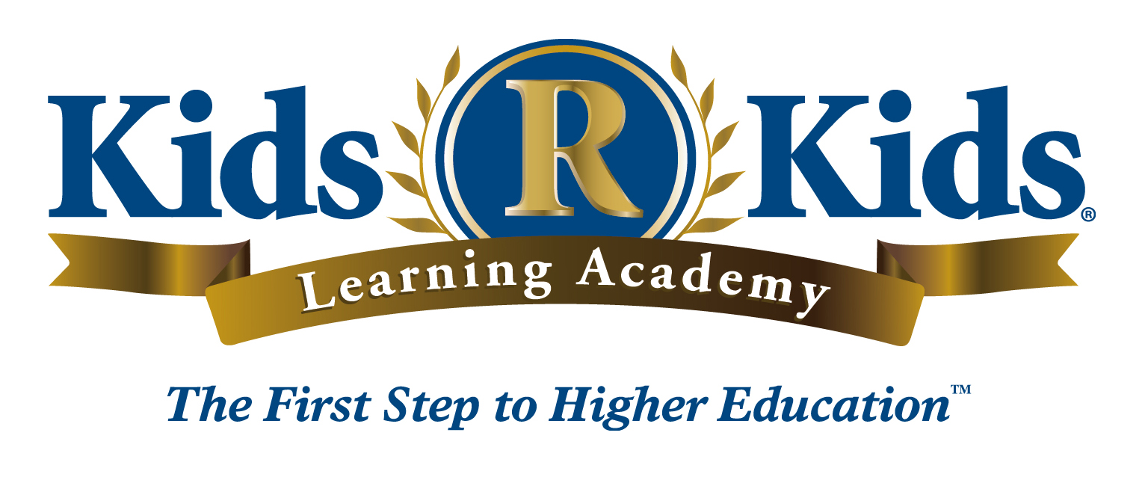

December 2018

Holidays Around the World
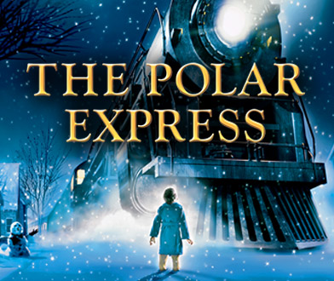
The train is coming in to station on Friday December 24, 2017.
We will have a Pajama day complete snacks and the holiday favorite, The Polar Express.
We will also close at 3 p.m.

This month our Fundamental Focus is Holidays around the world. As we explore each week’s theme, the children will expand their knowledge of different holiday celebrations around the world and how they integrate into our everyday lives.
Our Holiday pictures will be on WEDNESDAY, December 5, 2018.
Please sign up your child(ren) on the list in their classrooms. There will not be retakes available!
It’s that time of year again! The annual Curriculum Fee will be due in January.
The Curriculum Fee is a yearly fee that covers consumable and non-consumable curriculum, educational, and art materials. This fee can be seen on your billing screen when you login your child(ren) at the end of January. CODE: 15OFF2019
Our Holiday Program will be Thursday, December 20th, at 7pm
$15 Off if you pay by December 31st!
($25 off for 2 or more children)
KRK Anniversary
12/6- Ms. Delores -12 years
12/7- Ms. Kisha- 9 years
12/21- Ms. Megan- 1 year

