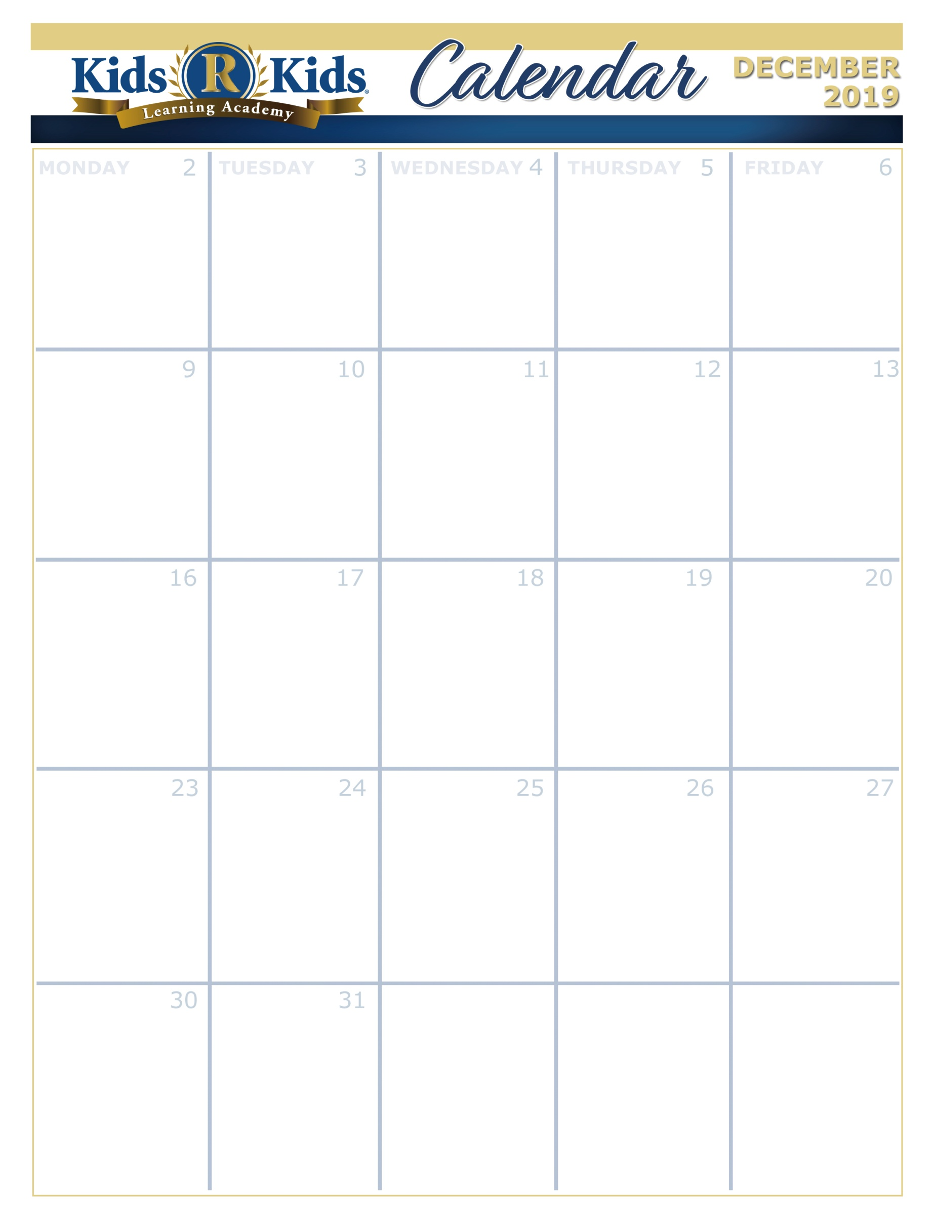

Close Early 3:30



Wear your New Years Hat!

Ugly Sweater

Day



Red Thursday



Green Tuesday

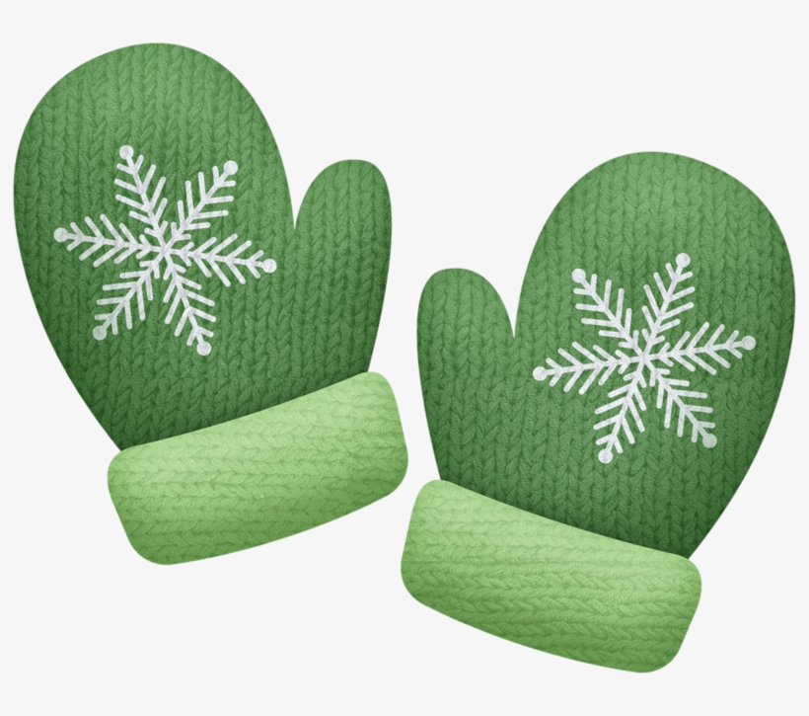

Suite 100-150 Family Feasts

Suite 200-250 Feasts for Family

Suite 300-350 The Little Red Hen

Suite 400-450 To the Market

Suite 500-600 Compare Objects

TOYS FOR TOTS all month.

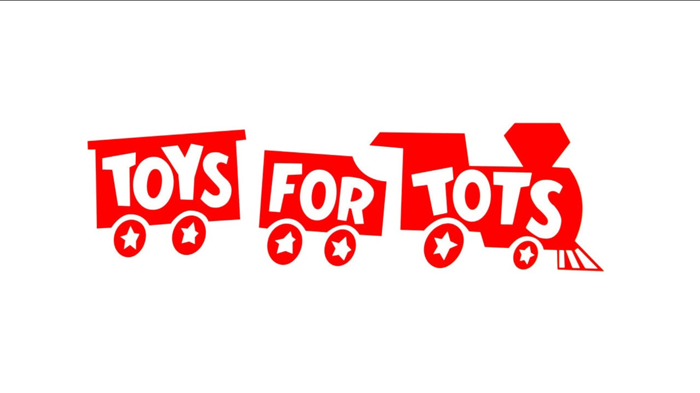

National Cookie Day



Giving Tuesday



(281) 557-0062

Pajamas & a Christmas Movie



Polar Express

CLOSED



Our Future looks Bright.



Wear your sunglasses!

Class Christmas Party @2:30

Each Class will go Caroling.

National Cocoa Day

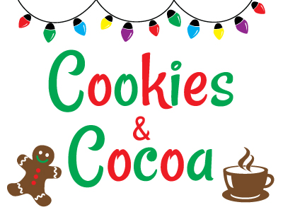

with parents at 2:30

National Maple Syrup day

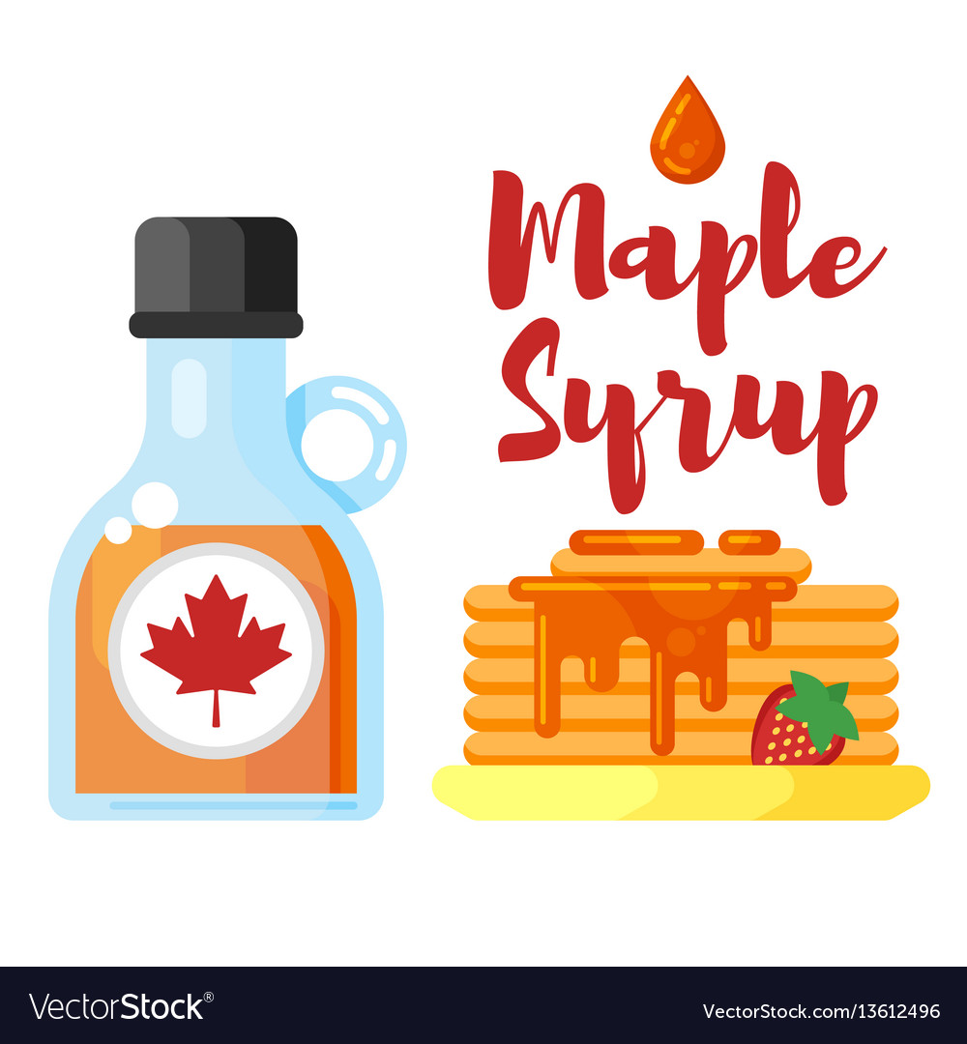

CLOSED



Suite 100-150 Sweet treats

Suite 200-250 Scrumptious treats

Suite 300-350 The Gingerbread Man

Suite 400-450 Celebrate People

Suite 500-600 New Years

Suite 100-150 Deck the Halls

Suite 200-250 Decking the Halls

Suite 300-350 Sensory Celebrations

Suite 400-450 Many Celebrations

Suite 500-600 Christmas

Suite 100-150 All Wrapped Up

Suite 200-250 Wrapped Up

Suite 300-350 Pretty Packages

Suite 400-450 Family Customs

Suite 500-600 What are animals like

Suite 100-150 All around the World

Suite 200-250 Around the World

Suite 300-350 Making Music

Suite 400-450 Winter Hat

Suite 500-600 Moving Objects

Extra Copy can go here…..