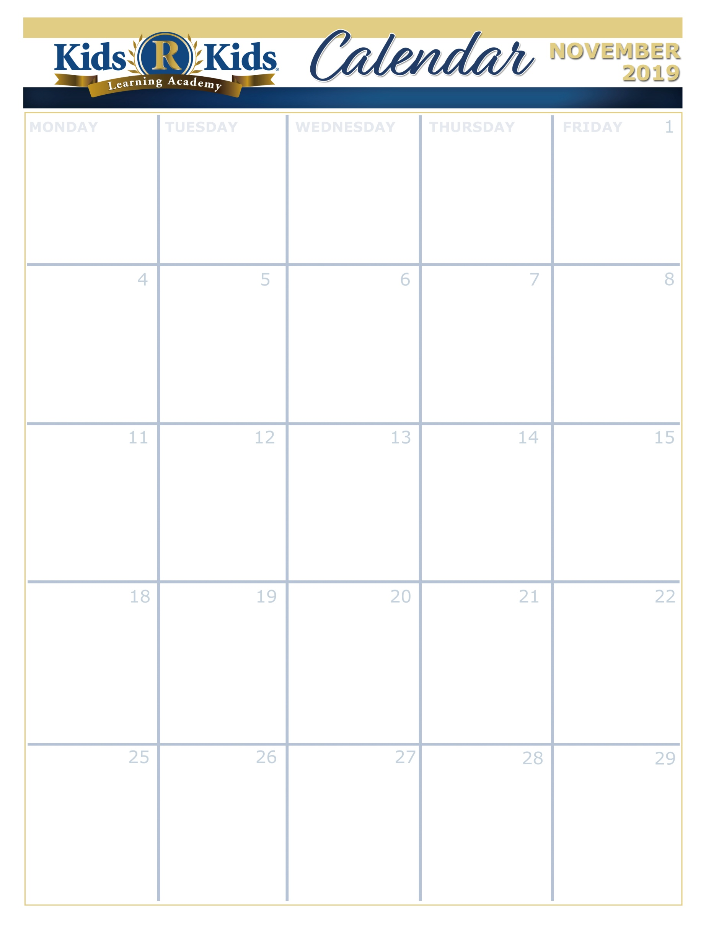





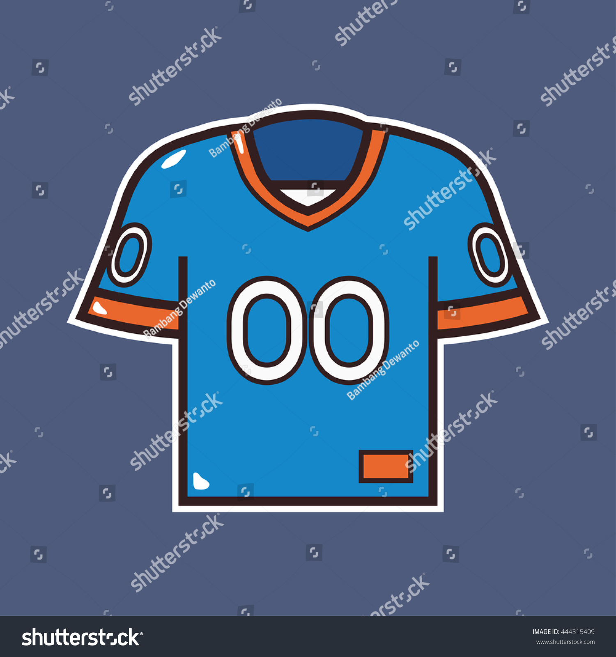

Football Day

Suite 100-150 Pumpkins

Suite 200-250 Pumpkins

Suite 300-350 Pumpkin Patch

Suite 400-450 Jazzy Autumn

Suite 500-600 What makes me Special?

[www.website.com](http://www.website.com) 000-000-0000

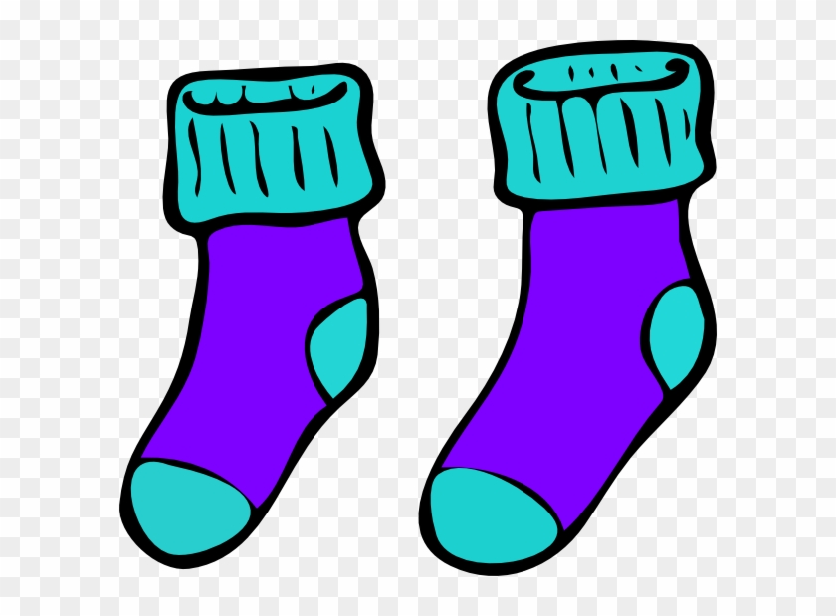

Bring a Pair of New Socks to Take to Nursing Home



I am Thankful for my Teacher Because......

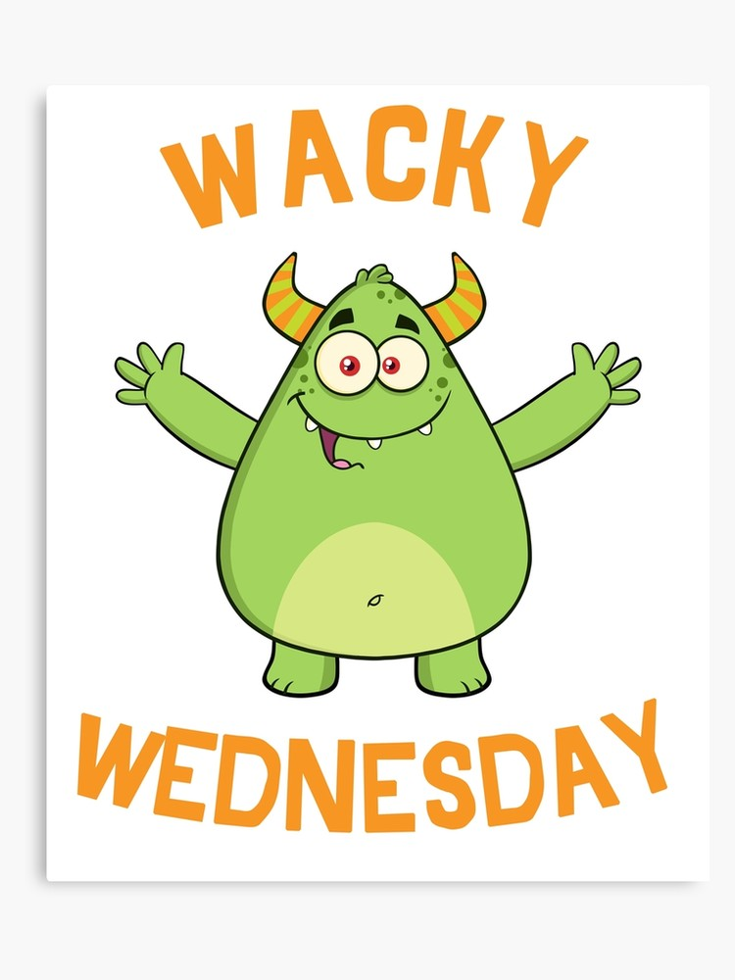

Wacky Wednesday





Thanksgiving Feast

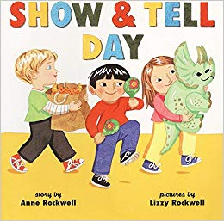

Show and tell



Show and Tell

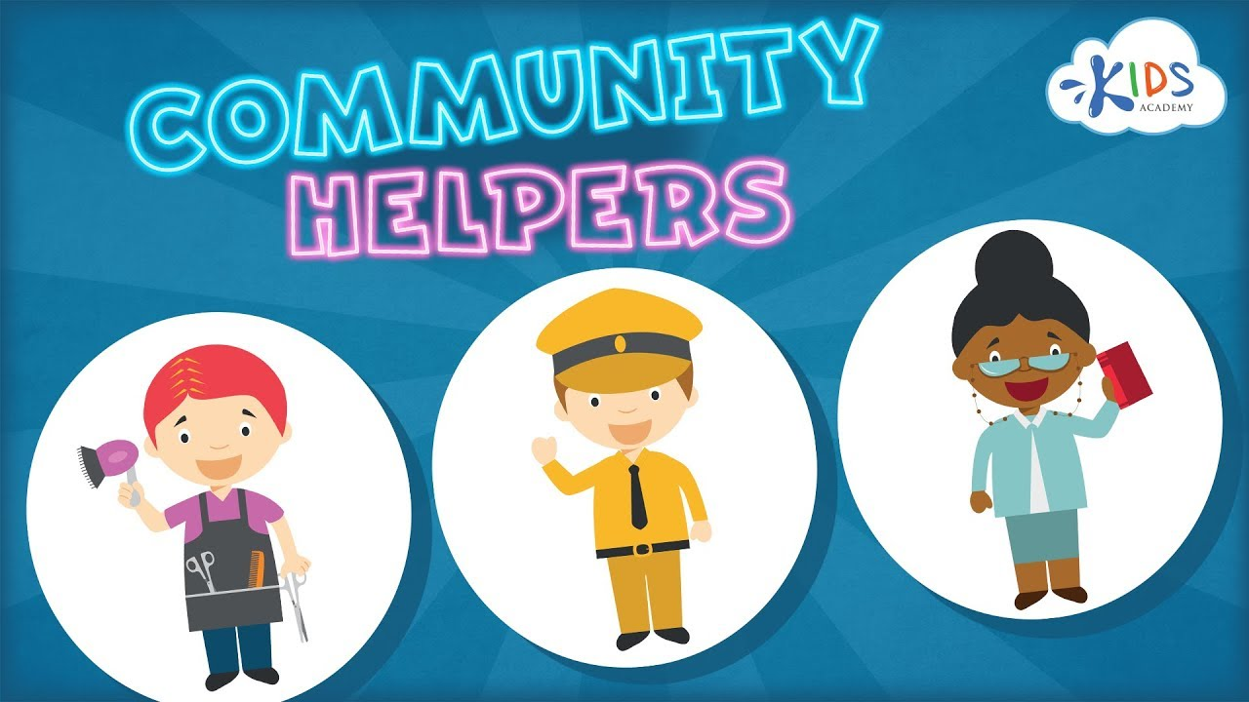

Dress like your Favorite Community Helper



Tacky Tuesday



Bring a Picture of your Family Member who is a Veteran



World Kindness Day

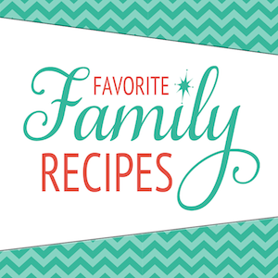

Share your Family's Favorite Recipe

Suite 100-150 My Family Cooks

Suite 200-250 Home and Family

Suite 300-350 Yummy for the Tummy

Suite 400-450 Gather Round the Good Stuff

Suite 500-600 Community Helpers

Suite 100-150 Kitchen Aromas

Suite 200-250 Cooking in the Kitchen

Suite 300-350 On the Go

Suite 400-450 Fun in the Kitchen

Suite 500-600 My Community

Suite 100-150 Kitchen Melodies

Suite 200-250 Cookbook

Suite 300-350 My Happy Home

Suite 400-450 Thanksgiving Feast

Suite 500-600 How Can I Help my Community?

Suite 100-150 Scarecrows

Suite 200-250 Black Spiders

Suite 300-350 Spinning Spiders

Suite 400-450 Dandy Fall Festival

Suite 500-600 Who Helps the Community?

Extra Copy can go here…..