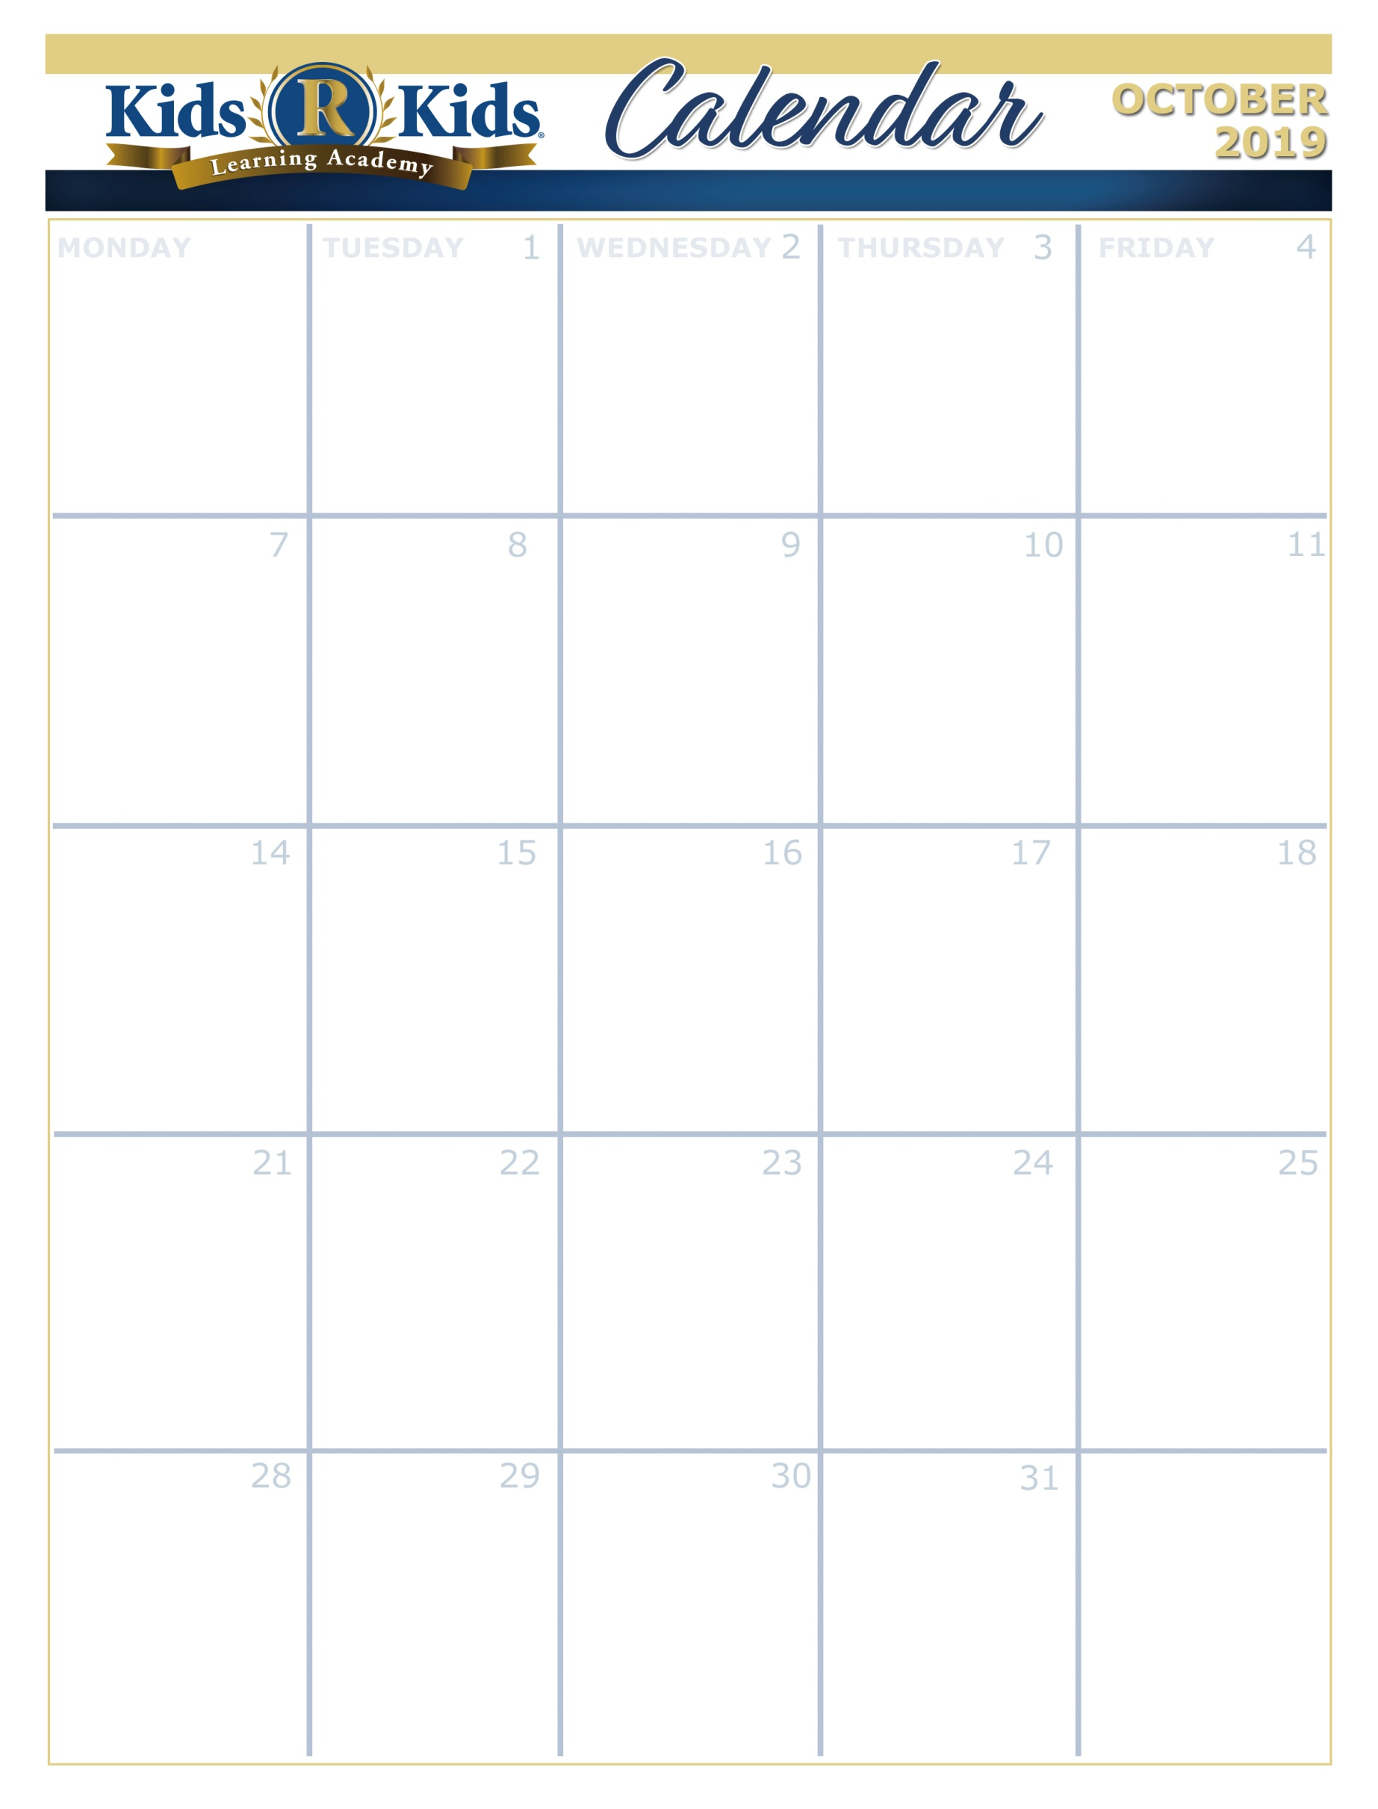

Suite 100-150 Places in my World

Suite 200-250 Places in my World

Suite 300-350 We need nurses

Suite 400-450 Say Hey to the USA

Suite 500-600 My Feelings

**Units of Learning**





Breast Cancer Awareness Month



[www.kidsrkidsspacecenter.com](http://www.website.com) 281-557-0062

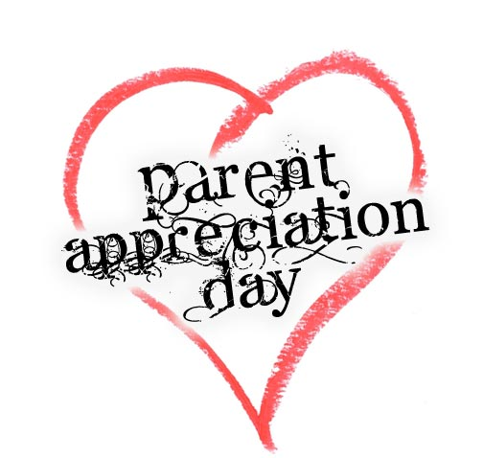

Parents Appreciation Day

Breakfast on the Go

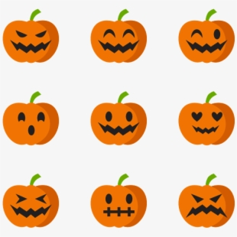

Vote for your Favorite Pumpkin on Facebook



Bring an Apple for your Teacher

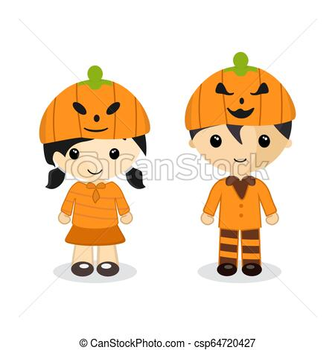

Wear All Orange



Classroom Parties

Pajama Day

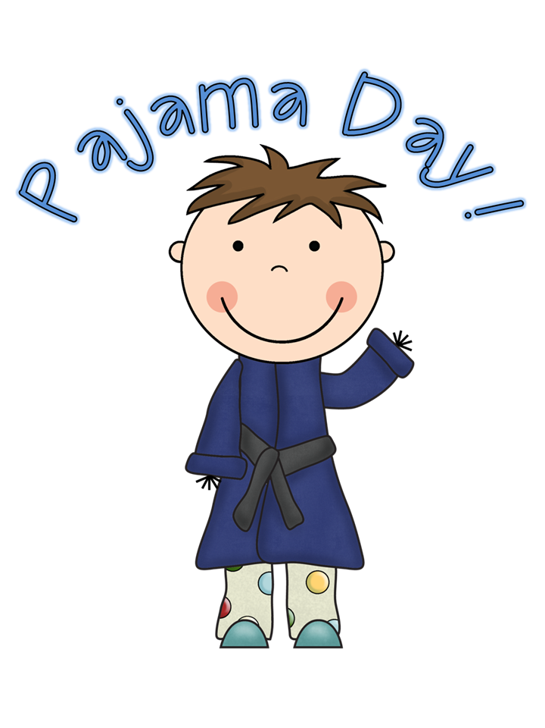

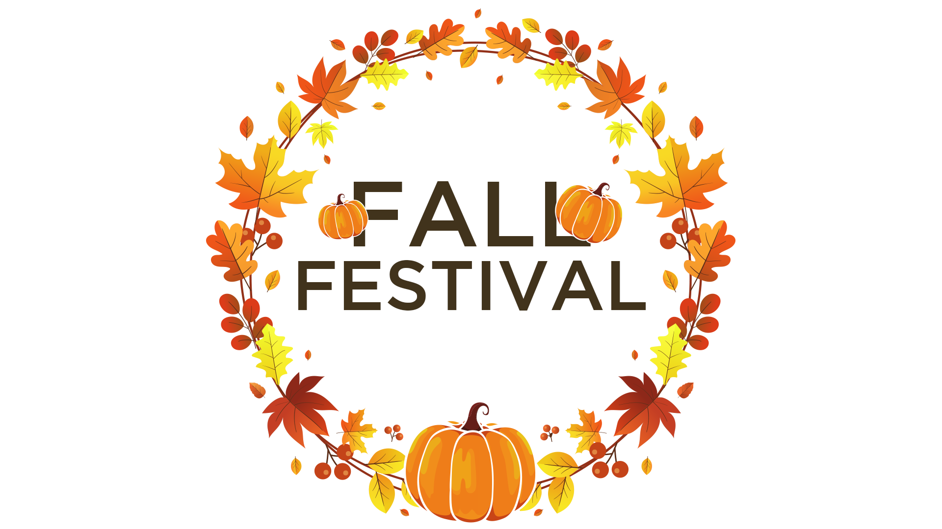

Fall Festival 7:00-8:30pm

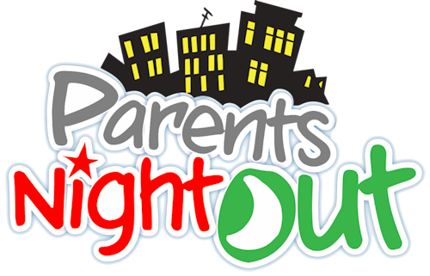

Parents Night Out 6:45-10:00pm

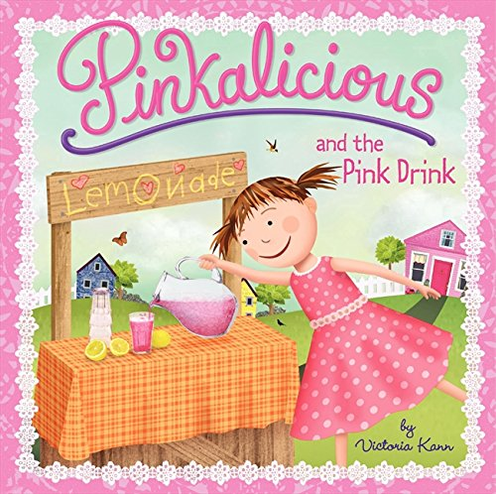

Dress all in Pink

Pink Lemonade Day

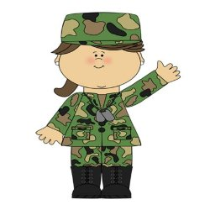

Hide from Breast Cancer.

Wear Camouflage

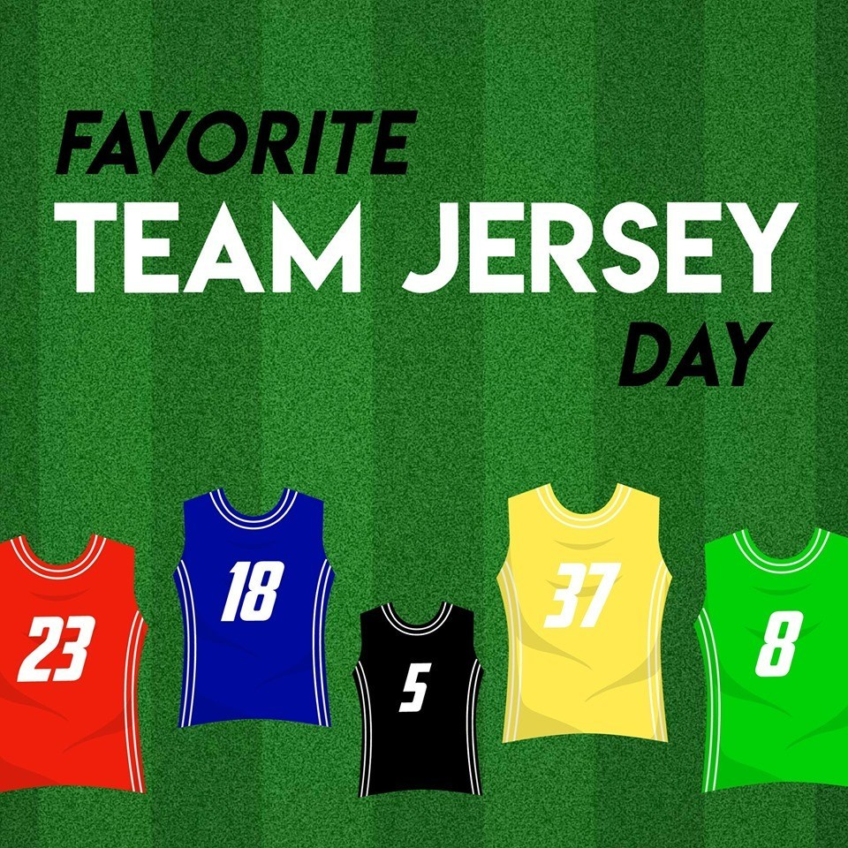

Let's Tackle Breast Cancer!

Wear your Favorite Team Jersey

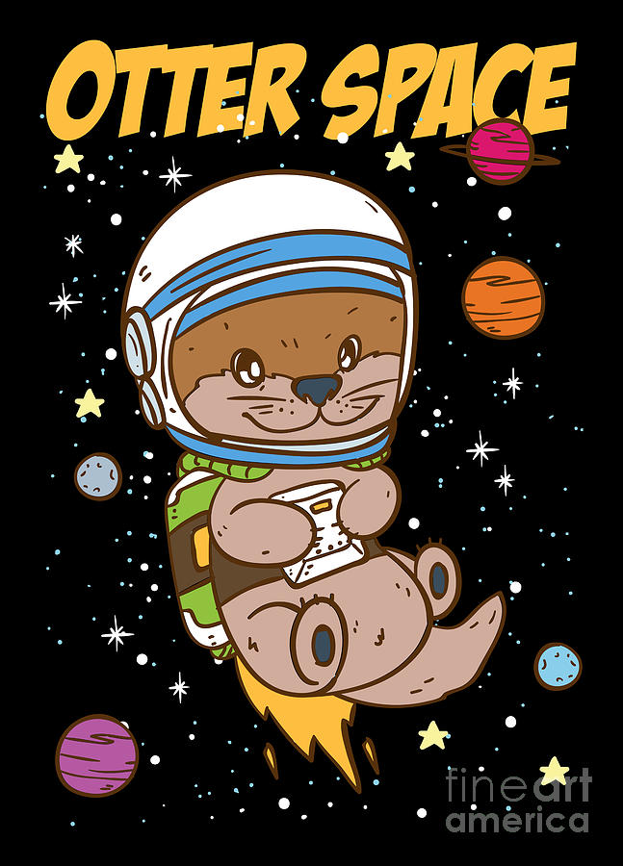

Breast Cancer out of this World!

Dress up like you're from Outer Space



Boss Day!

Wear gold and yellow to Spread Awareness of Childhood Cancer



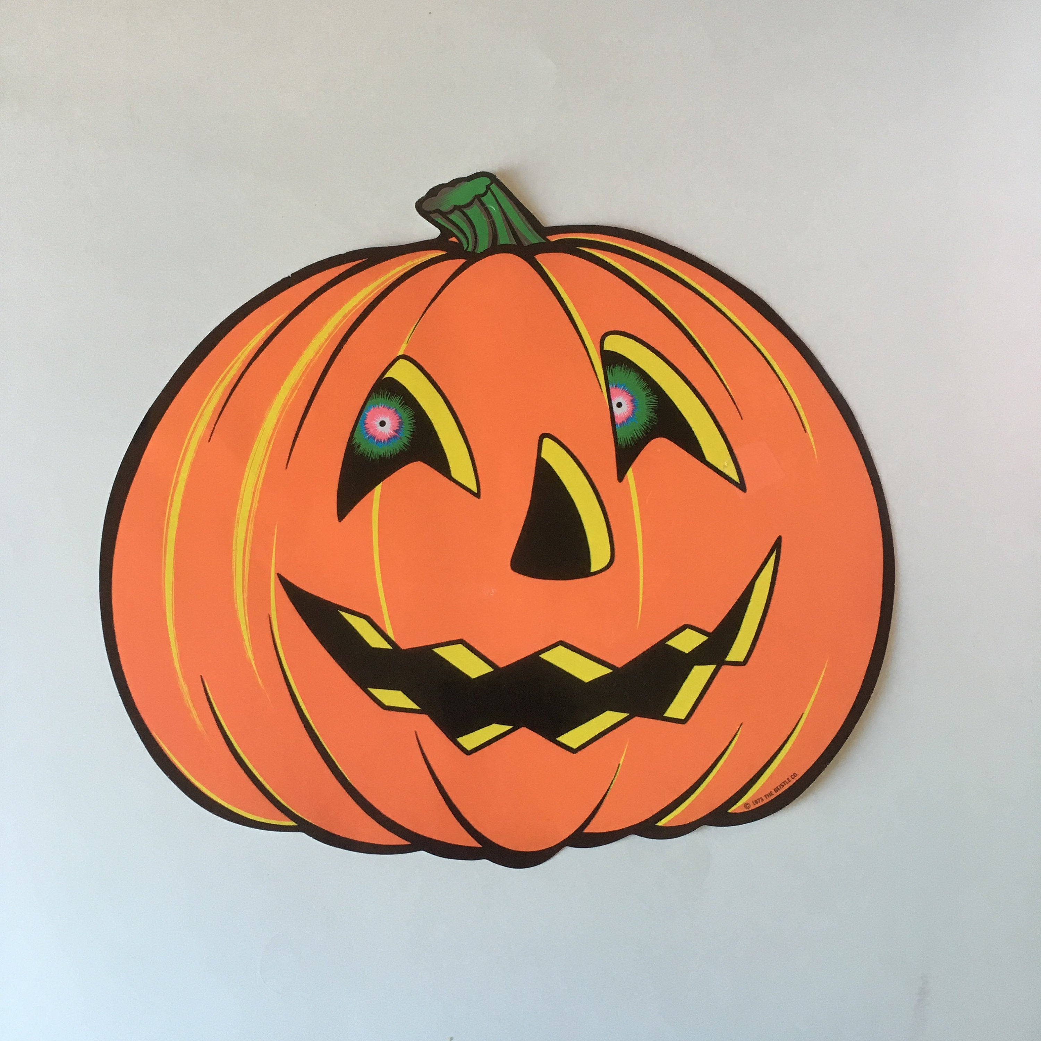

Pumpkin Decoration Contest.

Every Classroom

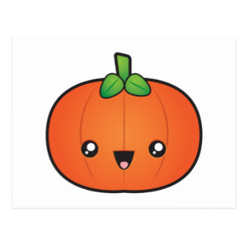

Bring a Small Pumpkin

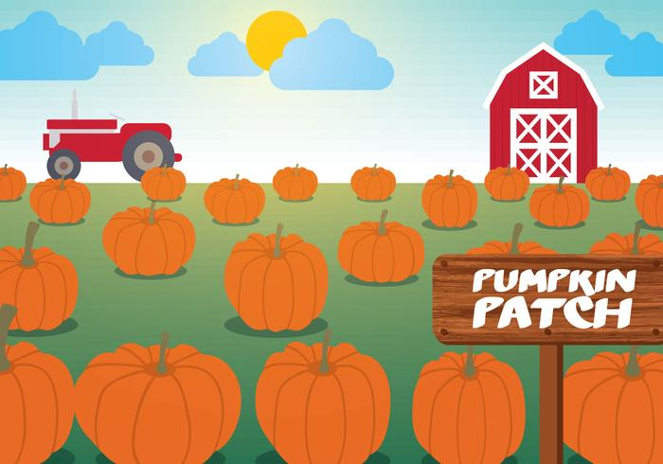

Pumpkin Patch

Suite 100-150 Pumpkins

Suite 200-250 Pumpkins

Suite 300-350 Pumpkin Patch

Suite 400-450 Jazzy Autumn

Suite 500-600 What makes me Special?

Suite 100-150 Apples

Suite 200-250 Apples

Suite 300-350 Apples for You and Me

Suite 400-450 Broadcasting Fall

Suite 500-600 What is a Family

Suite 100-150 Trees

Suite 200-250 Trees

Suite 300-350 Terrific Trees

Suite 400-450 Apples Stuff

Suite 500-600 My Family

Suite 100-150 Animals in my World

Suite 200-250 Animals in my World

Suite 300-350 Delivering the Mail

Suite 400-450 Kids Know

Suite 500-600 My Body

Extra Copy can go here…..