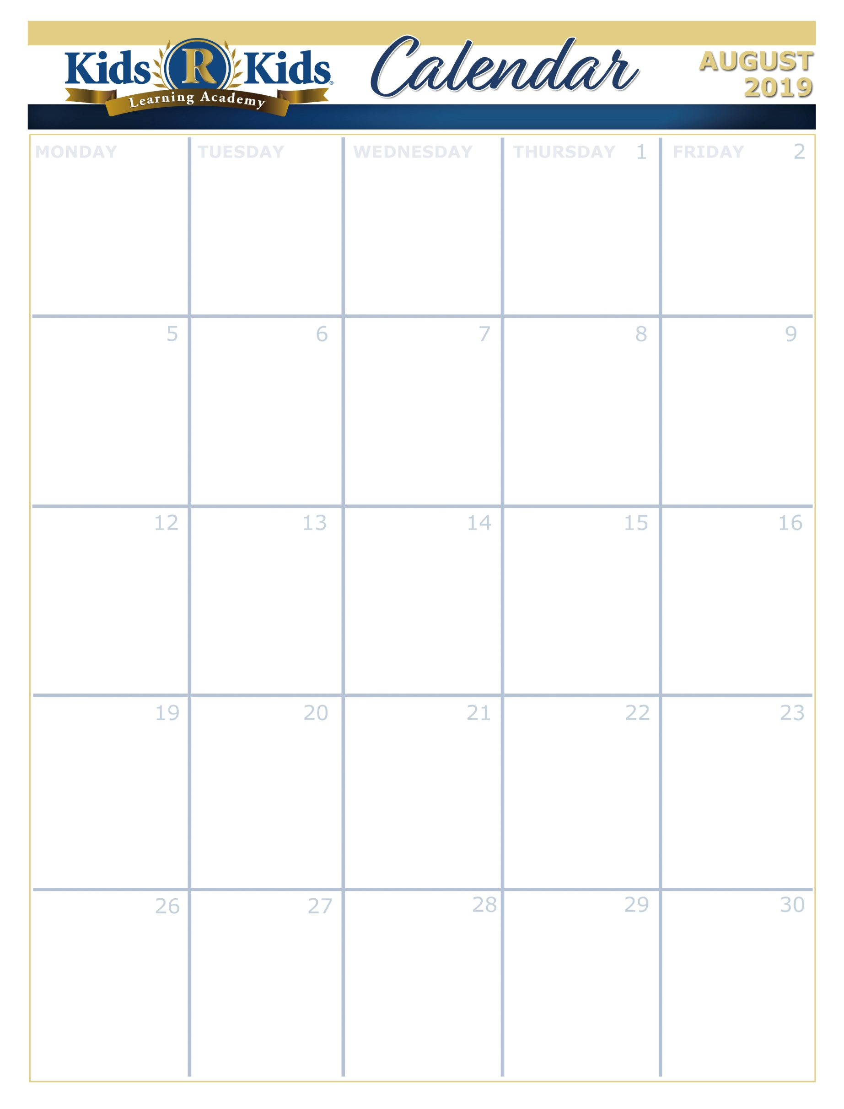

Suite 100-200 Me, Myself and I

Suite 250 Me, Myself and I

Suite 300-350 It's Nice to be Nice

Suite 400-450 Just Me

Suite 500-600 What Happens at School

**Units Of Learning**

Suite 100-150 Gone Fishing

Suite 200-250 Warm Winds

Suite 300-350 Up in the Sky

Suite 400-450 Happy Campers

Suite 500-600 Summer Celebration

[www.wkrkspacecenter.com](http://www.website.com) 281-557-0062

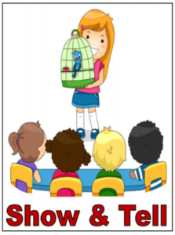



6:30-8:30pm

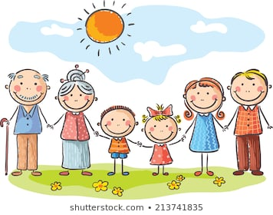

Bring a picture of your family



Book Lovers Day!



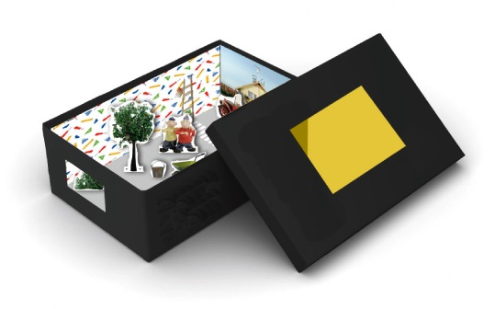

Bring a Board or show box about yourself



Friendship Bracelet



Summer Pizza Party



Recycle day

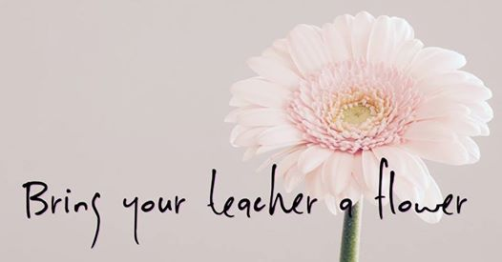

Bring a flower for your teacher





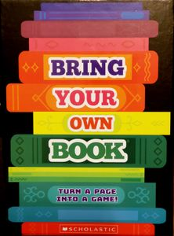

Bring your own book.

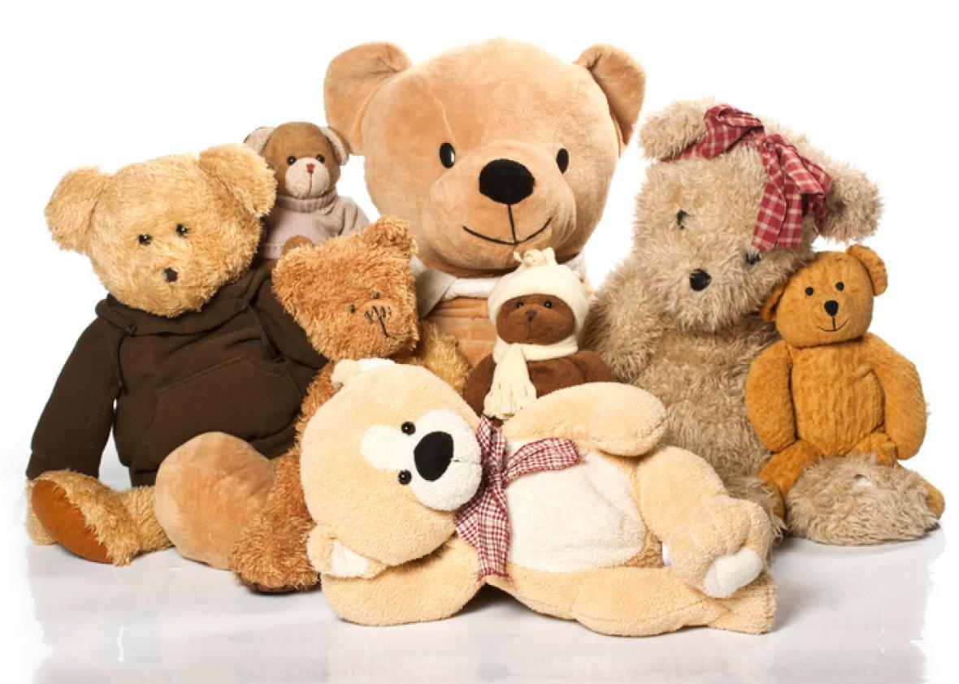

Bring your favorite small stuffed animal



Wear Orange day!

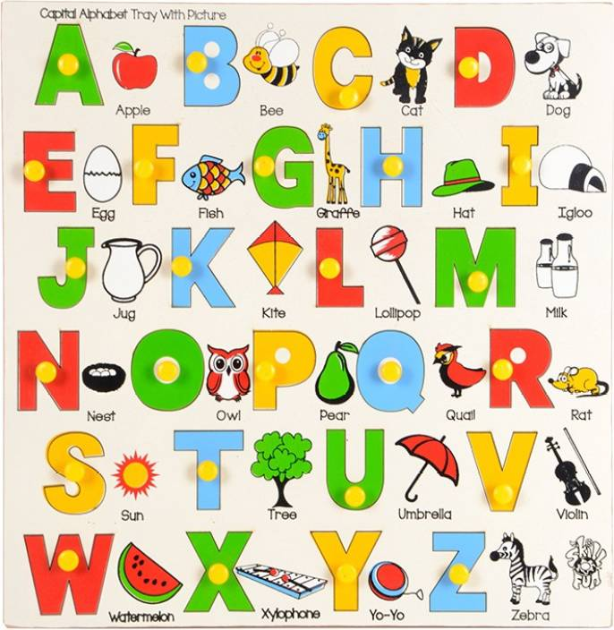

Alphabet Bowl

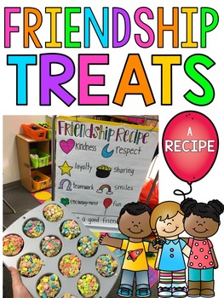

Bring a special treat to share with a friend

Suite 100-200 Welcome

Suite 250 Welcome

Suite 300-350 Welcome

Suite 400-450 Welcome Suite 500-600 Create your Own (Welcome to School)



Suite 100-200 Outrageously Orange Summer

Suite 250 Bye-Bye Summer

Suite 300-350 Crawling into Fall

Suite 400-450 Summer Shout Out

Suite 500-600 Summer Celebration

Suite 100-200 Grassy Green Summer

Suite 250 Beautiful Flowers

Suite 300-350 Going Green

Suite 400-450 Smile Awhile

Suite 500-600 Celebrate Summer With Books

Extra Copy can go here…..