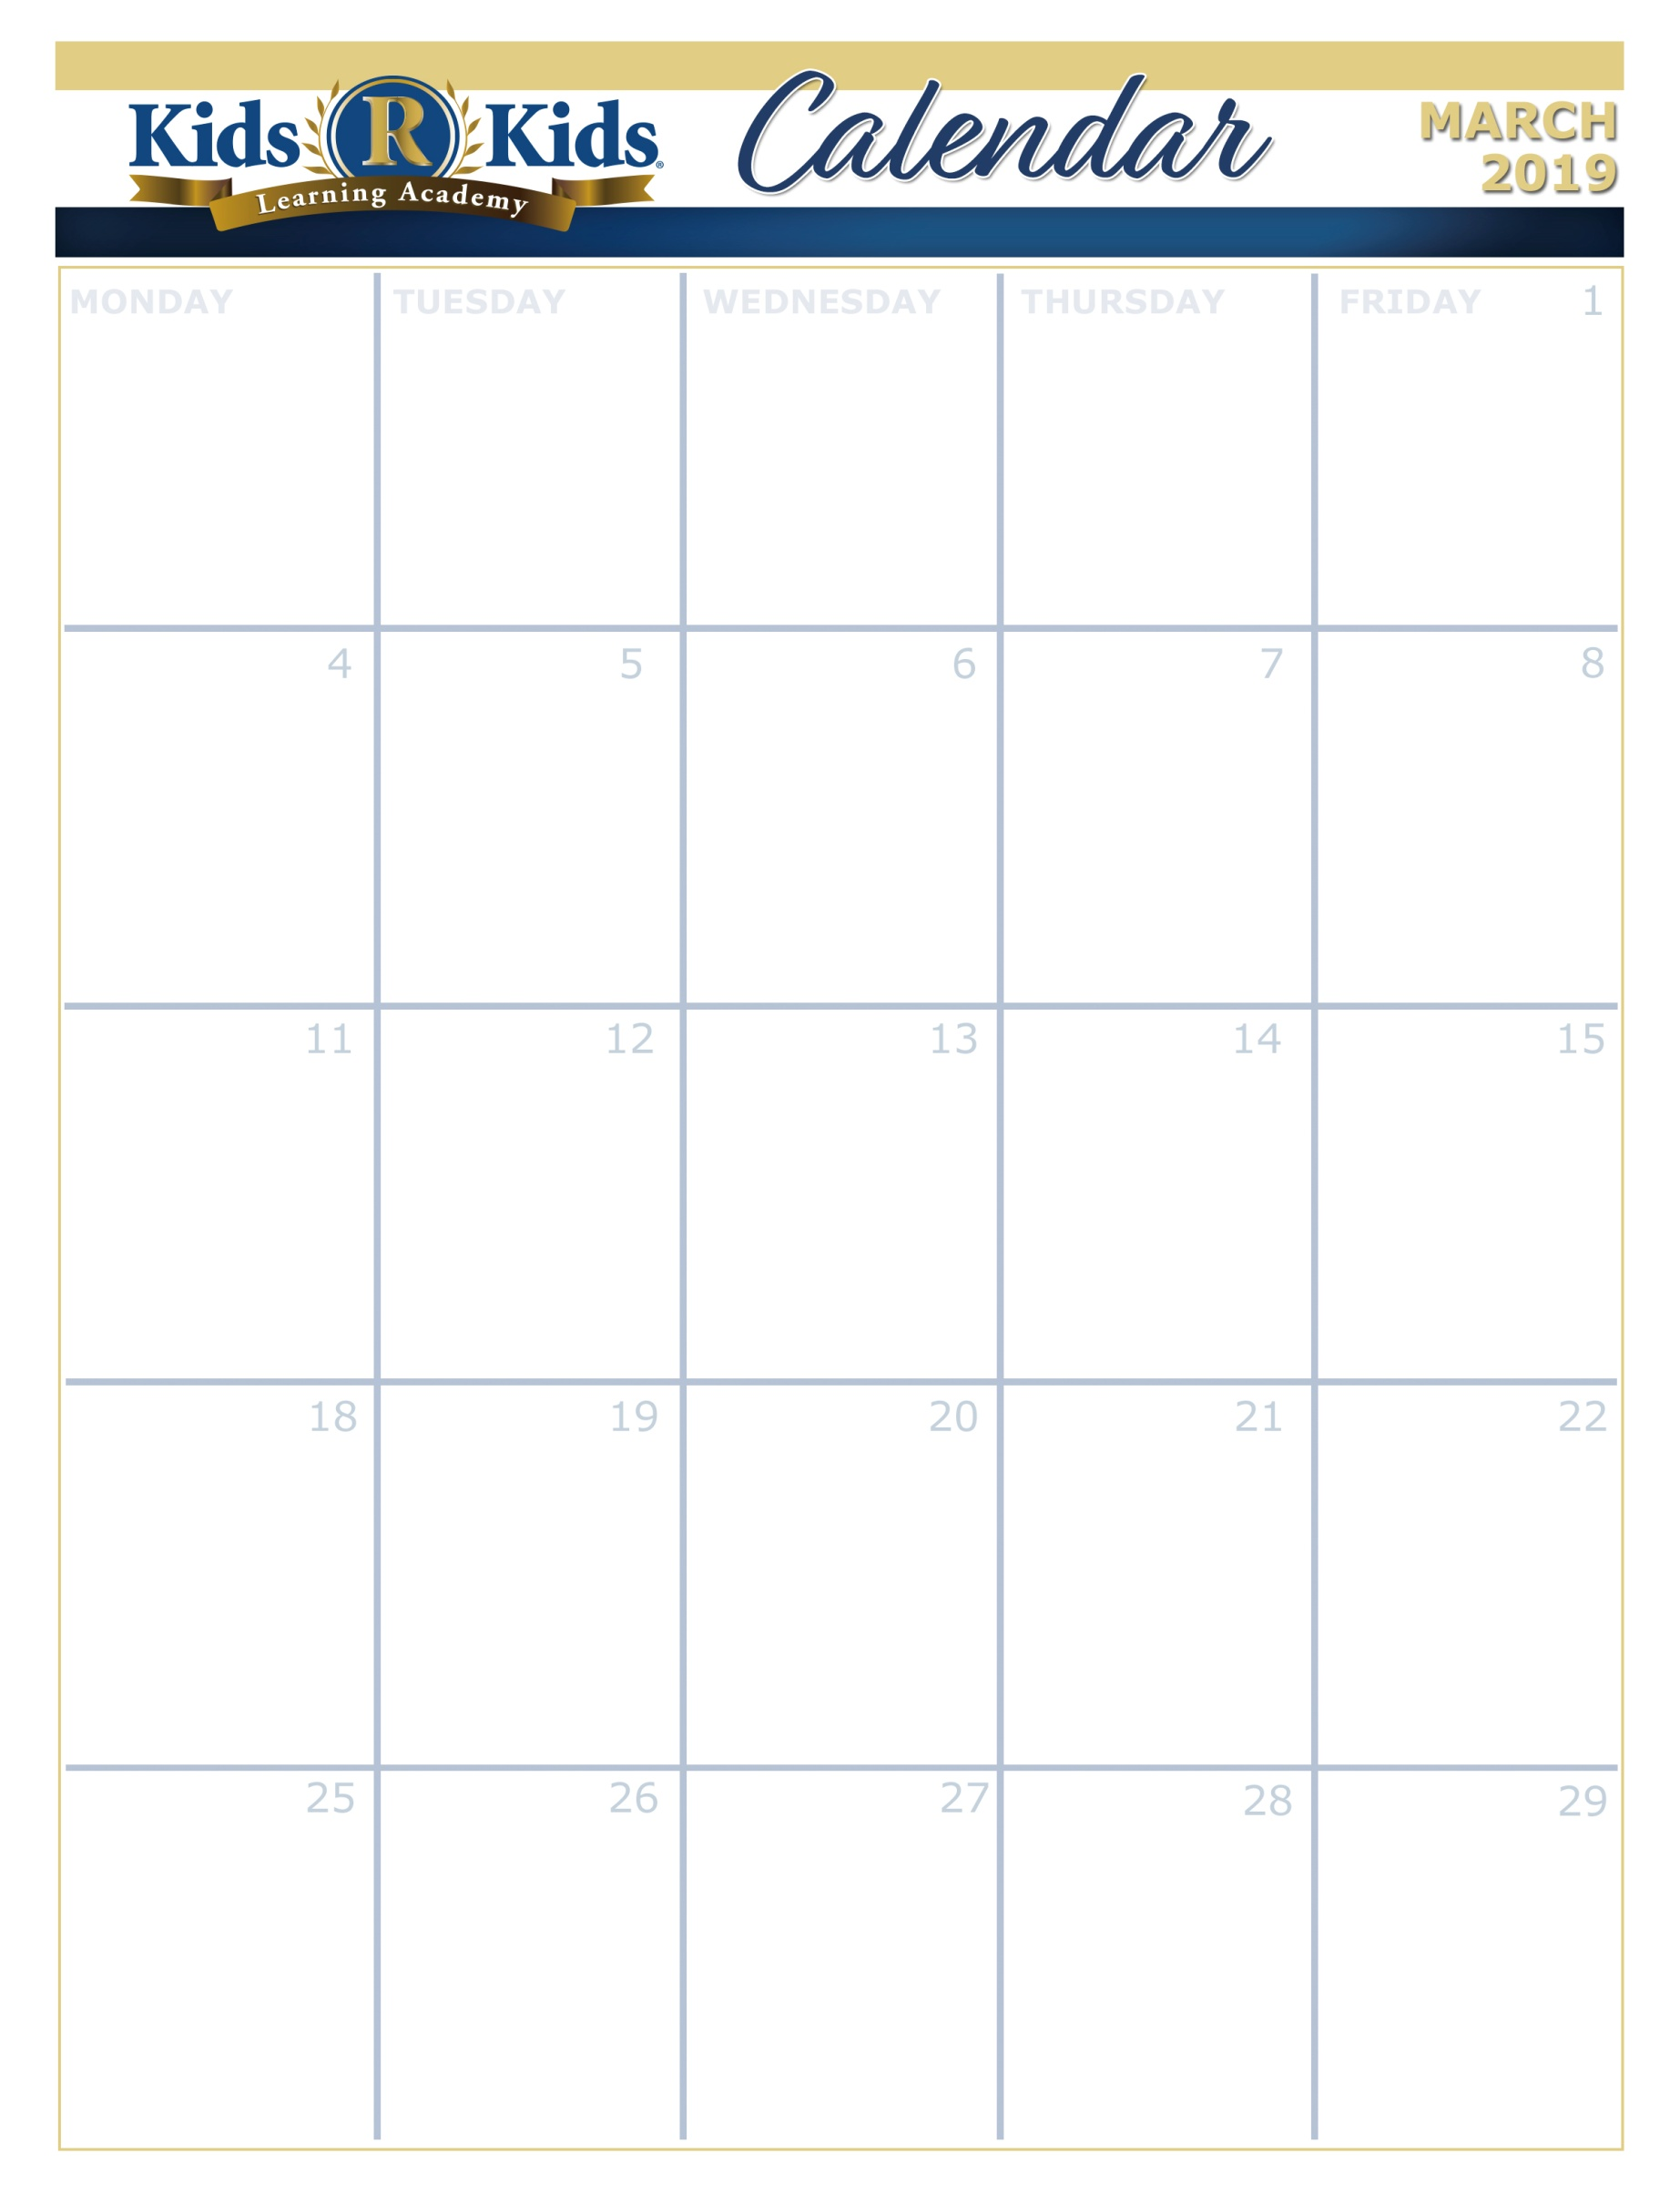

C:\Program Files (x86)\Microsoft Office\MEDIA\CAGCAT10\j0335112.wmf

What Can I Learn About Earth And Sky

What Are Good Healthy Habits?

Why Is Caring For The Earth And Sky Important?

What Can I Learn About Day And Night?

What Weather Can I Observe Each Day?

Ash Wednesday

[www.kidsrkidsspacecenter.com](http://www.website.com) 281-557-0062

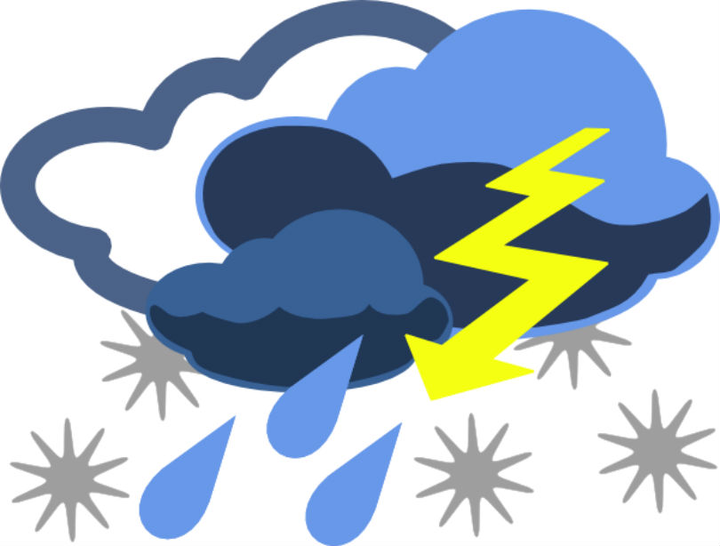



S.T.E.A.M.

Lemon Burst



Spring Hat Parade





Mardi Gras

Tasty Tuesday







Wear Green

Extra Copy can go here…..