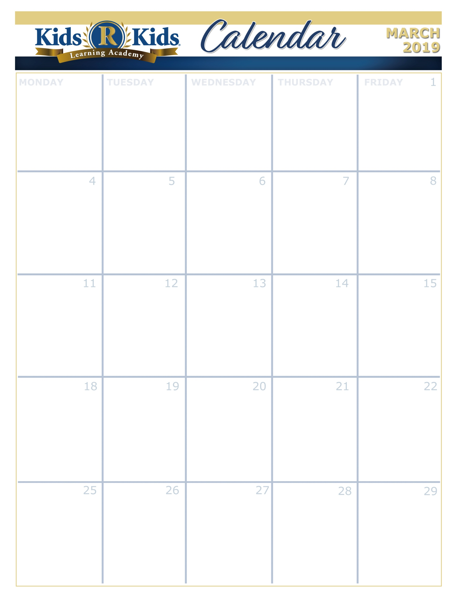

Puffy, Fluffy, Clouds

Whirlying Wirly Birds

Starlight Starbright

Healthy Me

Happy Shiny Teeth

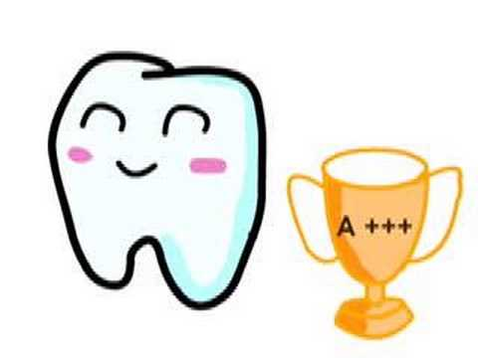

Ash Wednesday

[www.kidsrkidsspacecenter.com](http://www.website.com) 281-557-0062

C:\Program Files (x86)\Microsoft Office\MEDIA\CAGCAT10\j0293828.wmf



S.T.E.A.M.

Lemon Burst

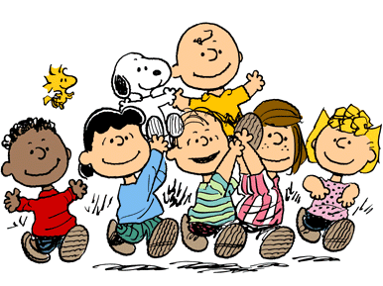

Spring Hat Parade





Mardi Gras

Tasty Tuesday



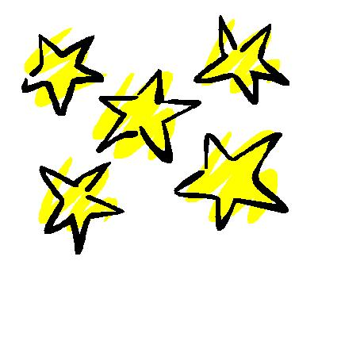



Wear Green

Extra Copy can go here…..