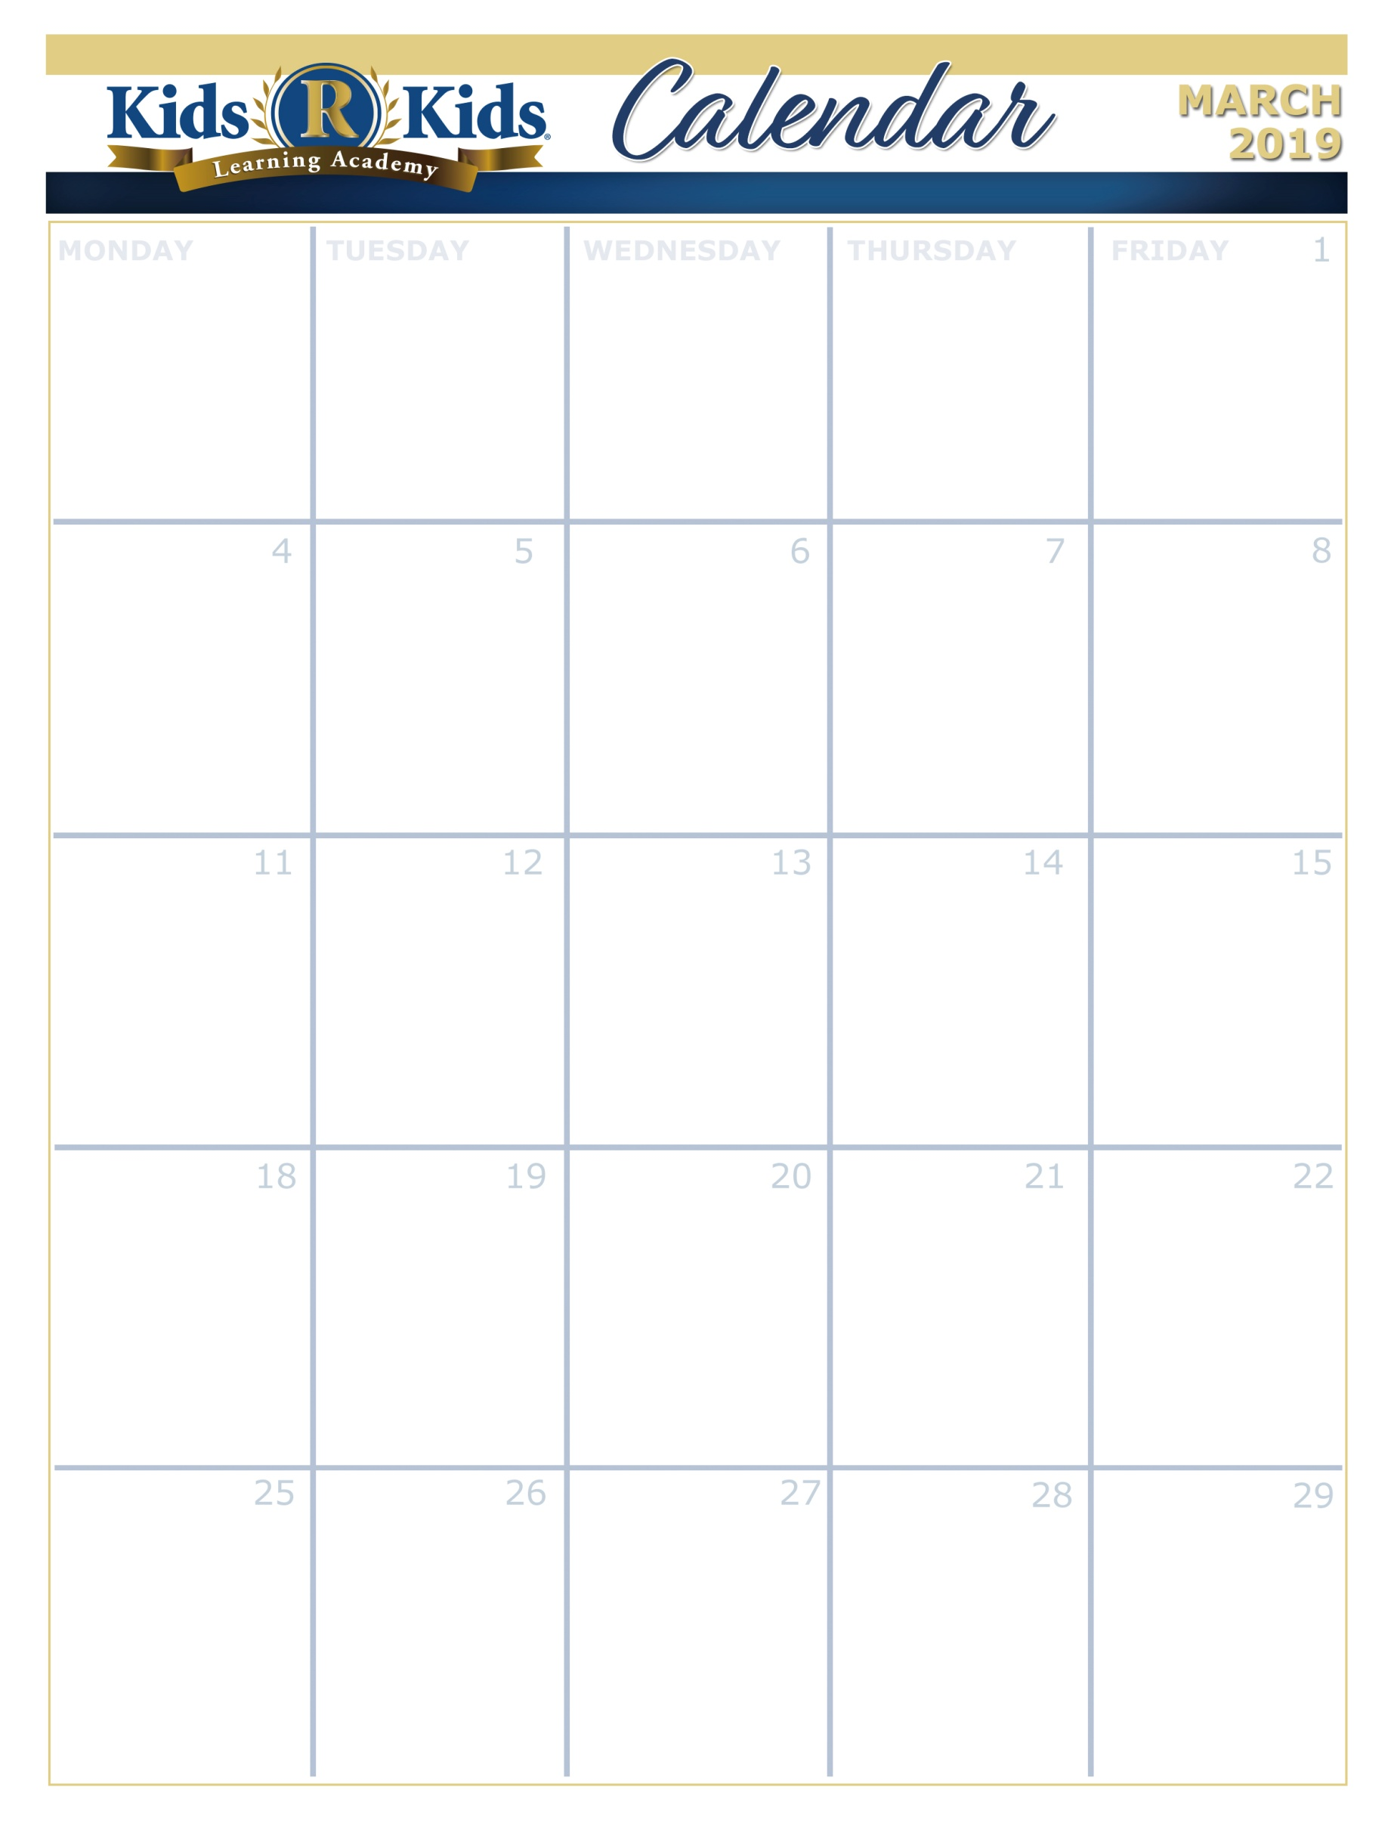

Happy, Healthy, Me

Raindrops And Rainbow

What Flies?

Goodmorning Sun

Kindness Counts

Ash Wednesday



[www.kidsrkidsspacecenter.com](http://www.website.com) 281-557-0062



S.T.E.A.M.

Lemon Burst



Spring Hat Parade





Mardi Gras

Tasty Tuesday





Wear Green

Extra Copy can go here…..