

What Can I Learn About The Earth Sky?

How Do Living Things Grow And Change?

How Do People Grow And Change?

How Do Plants Grow And Change?

How Do Animals Grow And Change?







Groundhog Day (2nd)

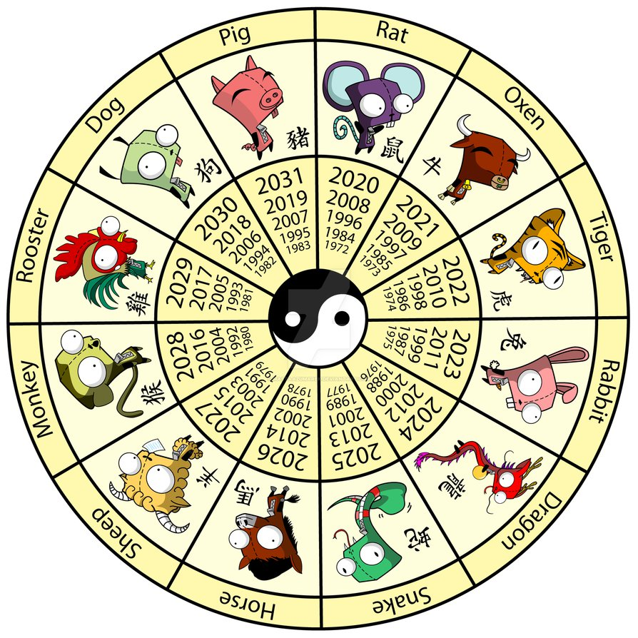

Chinese New Year

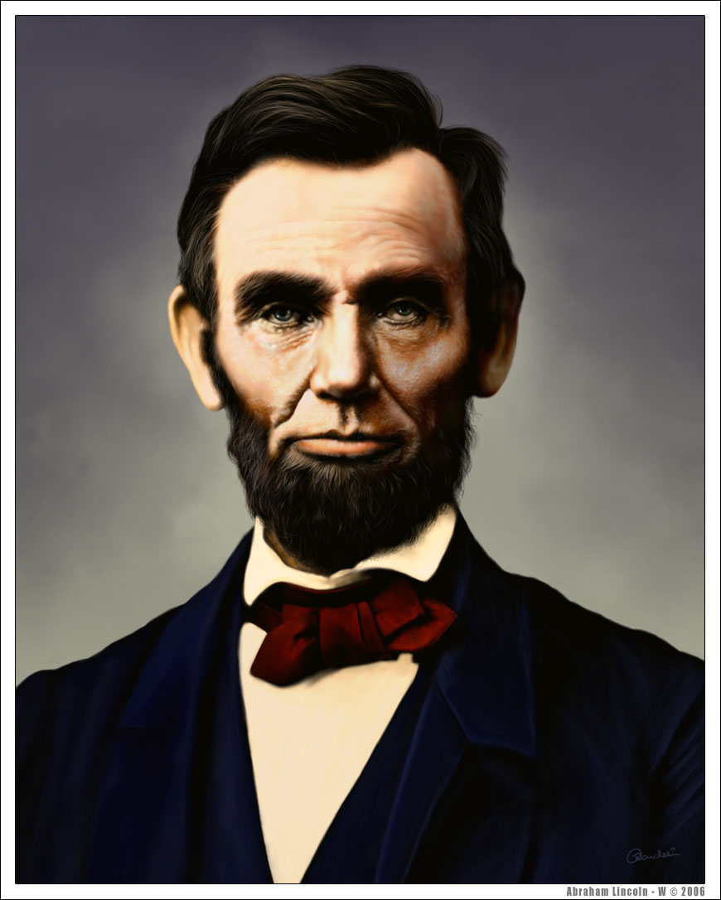

Abraham Lincoln Birthday

[www.kidsrkidsspacecenter.com](http://www.website.com) 281-557-0062



Wear Pink & Red

Valentine Parties

@ 2:30



Bring A New Pair Of Socks



Sock Sorting Activity



Go Texan Day

CCISD CLOSED



Wear your favorite team attire



Daddy & Daughter Dance 6:30-7:30p.m

Wear red, white, and blue.

CCISD CLOSED



Wear Green

Extra Copy can go here…..