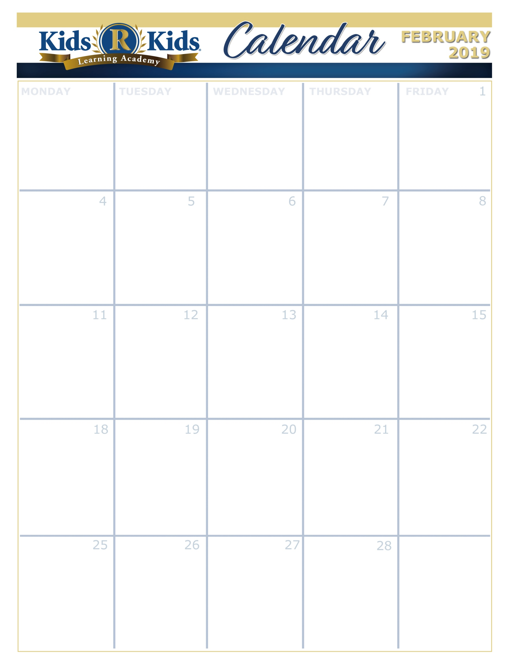

Happy, Healthy, Me

Love Is In The Air

Animals In The Winter

Wee Care

Bundle Up







Groundhog Day (2nd)

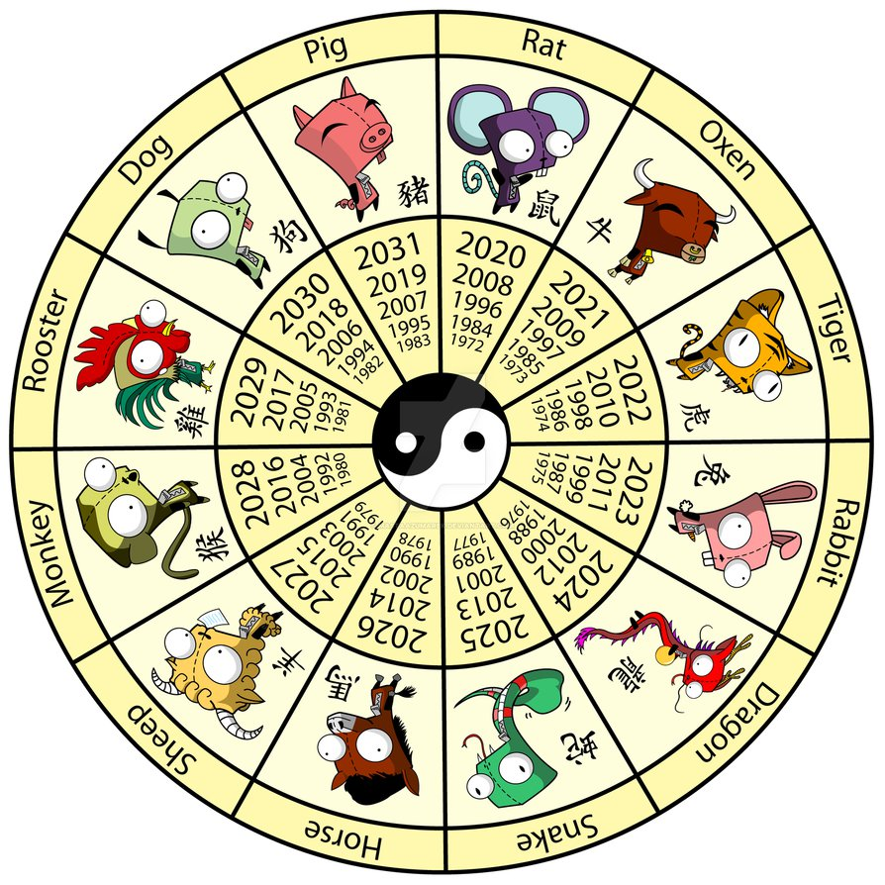

Chinese New Year

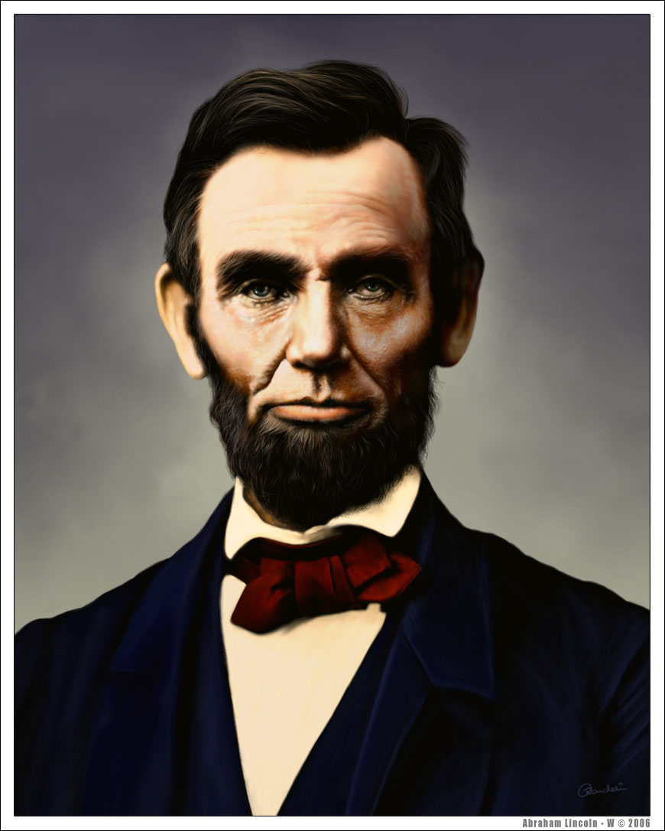

Abraham Lincoln Birthday

[www.kidsrkidsspacecenter.com](http://www.website.com) 281-557-0062



Wear Pink & Red

Valentine Parties

@ 2:30

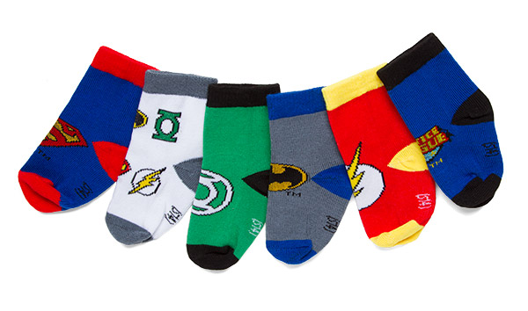

Bring A New Pair Of Socks

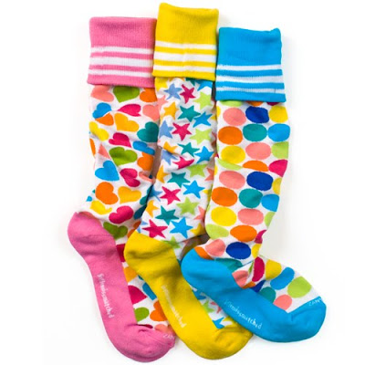

Sock Sorting Activity



Go Texan Day

CCISD CLOSED



Wear your favorite team attire



Daddy & Daughter Dance 6:30-7:30p.m

Wear red, white, and blue.

CCISD CLOSED



Wear Green

Extra Copy can go here…..