January 2019- Important Dates:
*January 1st: New Year’s Day (Kids ‘R’ Kids CLOSED)
*January 4th: National Spaghetti Day (Be ready for Spaghetti for lunch)
*January 10th: National Chocolate Day (Enjoy a piece of Chocolate)
*January 15th: National Wear A Hat Day (Wear your Hat!)
*January 18th: Winnie The Pooh Day (Winnie The Pooh Crafts)
*January 20th: National Cheese Day (Eat some Cheese!)
*January 21st: Martin Luther King Day (Cy-Fair ISD CLOSED)
-Downtown Houston has a MLK Parade @ 10 AM (http://www.mlkgrandeparade.org)
*January 23rd: National Handwriting Day (Let’s write today)
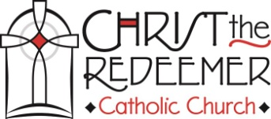
*January 28th: National Fun At Work Day (Have Fun!)
*January 28th to February 1: CTR Catholic School week
*January 31st: Class Picture Day (Dress to Impress) Starts at 9:00 AM

