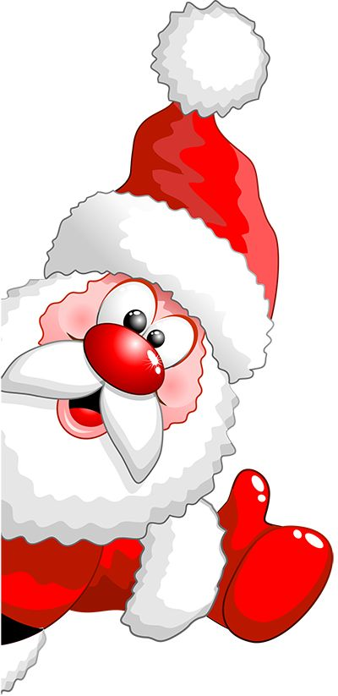

December 2018-Important Dates:
The week of December 17-21, 2018
December 17th: Santa or Elf Hat Day
December 18th: Holiday shirt & socks Day
December 19th: Ugly Sweater Day
December 20th: Dress to Impress (Party Day)
December 21: Pajama Day & Movie “The Polar Express”

*December 20th: Classroom Christmas Party
-Suite 100-450 party @ 2:30 PM -Suite 500-55 party @ 1:00 PM
-School Age Children party @ 4:30 PM
*December 21st: Pajama Day & The Polar Express Movie Day
*December 24th: Christmas Eve (Kids ‘R’ Kids CLOSED)
*December 25th: Christmas Day (Kids ‘R’ Kids CLOSED)
*December 28th: National Playing Cards Day
*December 31st: New Year’s Eve (Kids ‘R’ Kids CLOSED)
*January 1st: New Year’s Day (Kids ‘R’ Kids CLOSED)
