Meet:
Miss Jasmine Miller
Office Assistant/Teacher
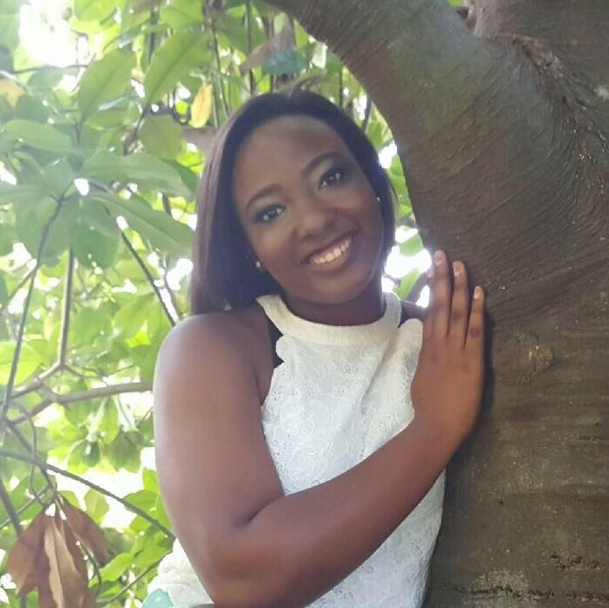

A Little Bit About Me:
I am a student at the University of
Houston. I am a BIG Houston
Sports fan. I also enjoy spending
time with friends and family.

Food: Mexican
Soft Drink: Tea & Lemonade
Book: The Outsider
Sports: Volleyball & Football
Fast Food: Chick-fil-A
Color: PURPLE
Candy: Twix
Season: Fall
Hobbies: Baking

