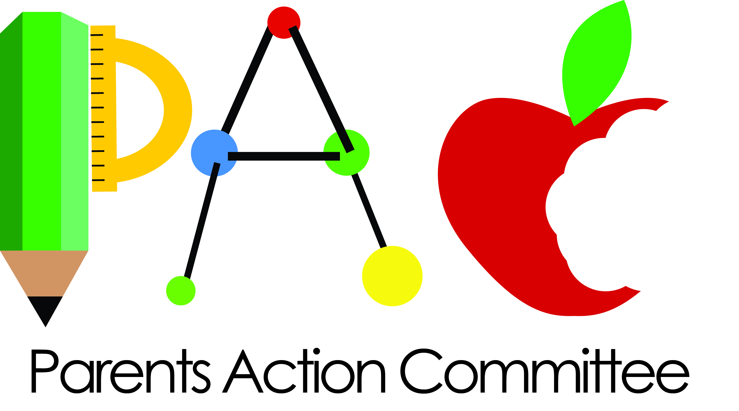

**YES!**

I want to help my child achieve success by becoming a member of Kids R Kids Parent Action Committee (PAC).

Name: _____________________

Address ____________________

___________________________

Home Phone: _______________

Cell Phone: _________________

I’m especially interested in:

____Event Planning

____Fundraising

____Mentoring

____Networking

____Working on new Initiatives

____ Classroom Parent

Other:__________________________________________________________________________________________________________________________________________________________________________________________________________________________________

**PAC’S SIX-FOLD PURPOSE**

* Assist the school in planning and producing special events, e.g., Wee Heart’s Dance, Open House.
* Provide feedback to the school on new initiatives.
* Assist with fundraisers for the purchase of items for the school or classrooms.
* Organize social events for parents at the school.
* Develop mentoring relations for parents, i.e., pairing parents whose children have been enrolled with parents of newly enrolled children or new moms with experienced moms.
* Develop parent networks that provide helpful information such as, pediatricians, dentists, baby sitters, restaurants, etc.

Ask any teacher, “What is the easiest thing a parent can do to help his or her child succeed in school?”

You’ll likely get a simple answer: “**Be involved.”**





**PAC** opportunities include:

* Mommy & Daddy University;
* Charity Fundraising;
* Event Planning;
* Volunteering;
* Classroom Parent.

**A**ll of these activities give you an occasion to get to know and interact with Kids R Kids Personnel and form a bond that will develop a sense of partnership and encourage cooperation that can only enhance your child’s learning experience.

**P**arents, you are your child’s most important advocate and teacher, so remember: every moment you devote to your child’s education is an investment in his or her future. Help your child succeed by becoming a part of the Kids R Kids family through membership in our Parent Action Committee.

**JOIN TODAY!**

**F**or decades, researchers and education professionals have studied the effects of parent and family involvement in a child’s education, and the conclusion is clear: parental involvement is an essential component of student achievement.

**W**ell-known authority, Dr. Joyce Epstein, Director of the Center on School, Family and Community Partnerships, John Hopkins University, developed a framework of six school/parent partnership practices that ultimately help students to thrive. These include, Parenting Support, Parent/Teacher Communication, Parent Volunteering, Home Learning, Joint Decision-Making and Collaborating within the Community.



**A**ccording to Dr. Epstein, some of the benefits of parental involvement in their children’s education include:

* Improved school attendance and behavior at school;
* Better adaptation to school;
* Increased motivation and self-esteem;
* Higher academic achievement.

**K**ids R Kids Cinco Ranch East management believes in parent/school cooperation and interaction, and we offer you an opportunity to be involved through membership in our Parent Action Committee (PAC). PAC gives you the chance to stay engaged in your child’s education on an integral level through numerous activities.