# May Every Moment of June be Filled with Joy.

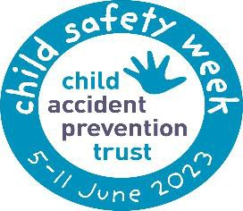

Centerville #33

## June 2025

KRK33 SUMMER CAMP IS OFFICALLY HERE!!

Kindergarten campers, Junior Campers, and Senior Campers are in for some out of this world FUN!

A few reminders to make your summer camp one to remember. On Field Trip days, your child must be here no later than 8:30am as buses leave the premises at 9:00am

# National Safety Week

Child safety, area concerned with limiting children's exposure to hazards and reducing children's risk of harm. Children are particularly vulnerable to accidents, and their safety requires different approaches from those for adults. Here are some conversations to have with your child about remaining safe.

Say it early, often, and very clearly, talk about uncomfortable feelings, talk about “tricky people.”, be specific, role-play, make kids the “boss” of their body, give simple steps for scary situations, talk about online stranger safety.

## Happy Birthday!

Carter C. –6/1

Zaheem- 6/2

Kartier- 6/7

Sage- 6/8

Richmond- 6/9

Carter A- 6/10

Peyton- 6/12

Amina- 6/13

Brynlee 6/218

Demir- 6/19

Leilani- 6/21

Seriya- 6/21

Makayiah-6/23

Journee- 6/28

Ms. Aniya *Curriculum Director* - 6/20

**Campin’ With Dad**

Join us for a camp-out Father’s Day celebration.

Dress ready to have a field day with your bundles of joy!

**Please arrive at 9:30am for special presentation**

1