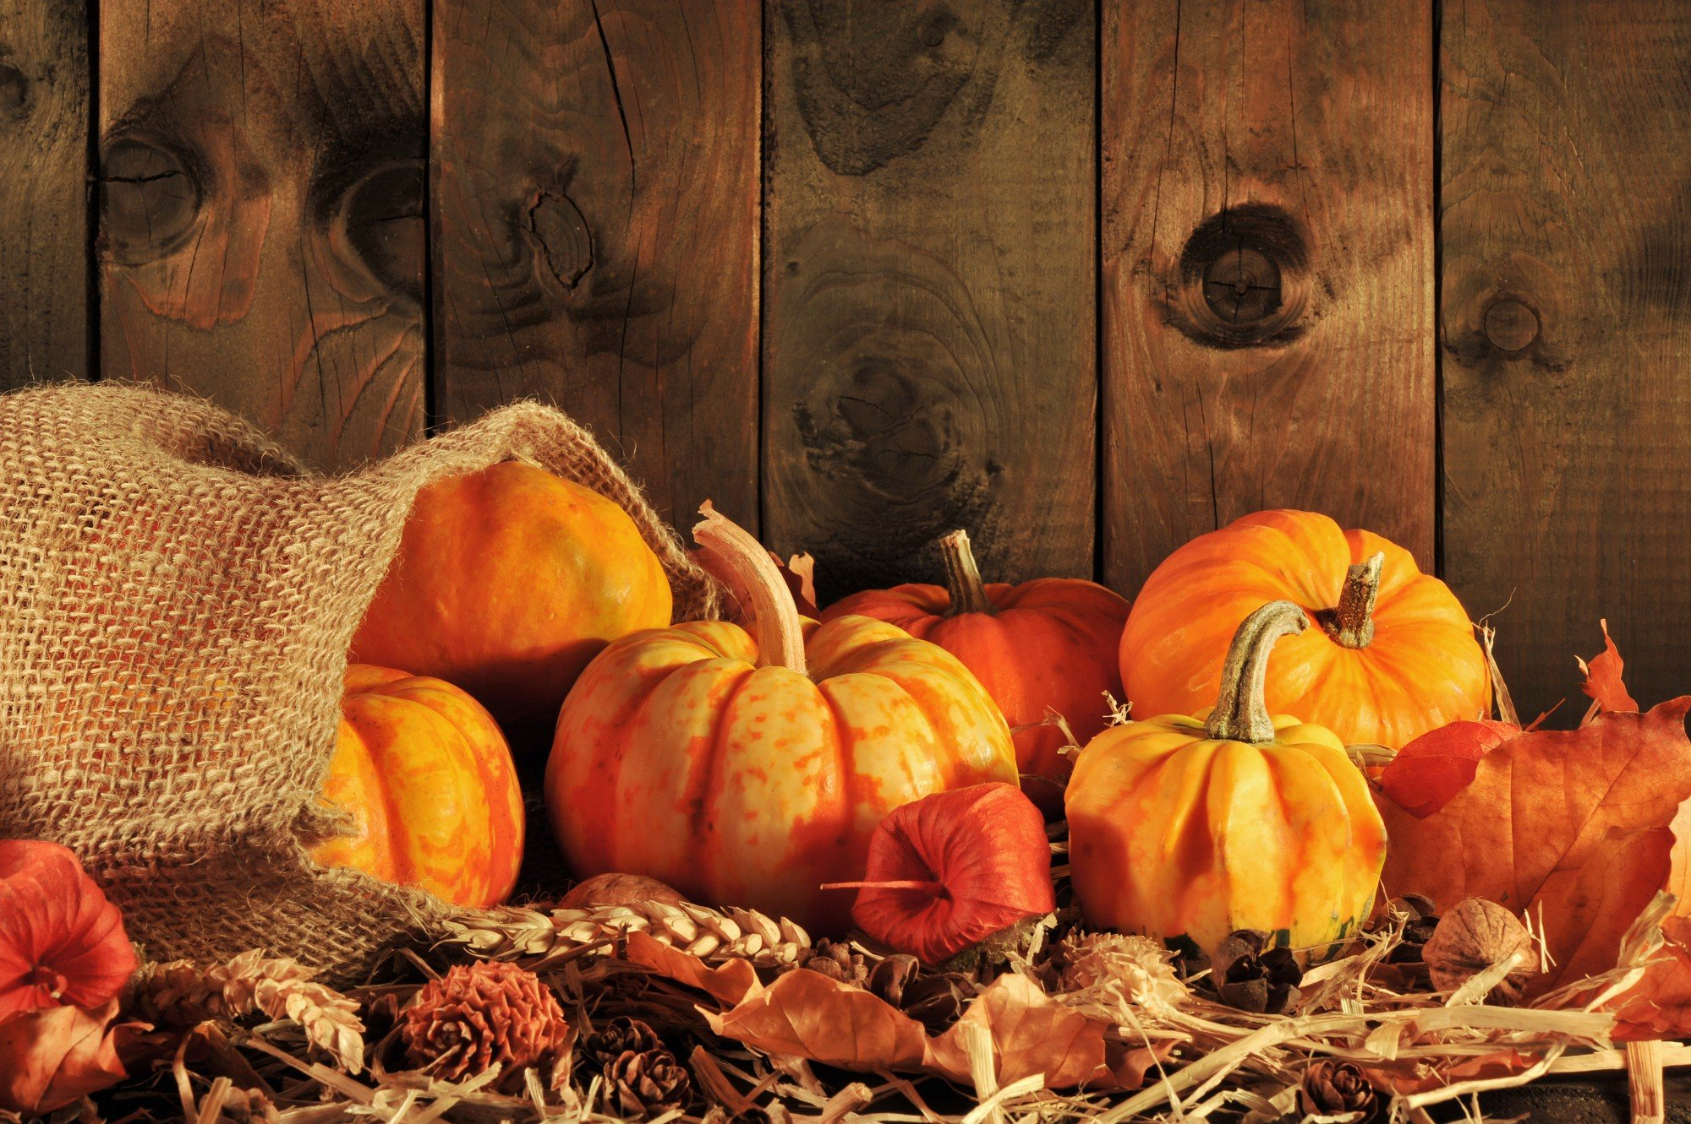

|  |  |  |  |  |  |  |
| --- | --- | --- | --- | --- | --- | --- |
| **sUNDAY** | **Monday** | **Tuesday** | **Wednesday** | ***Thursday*** | **Friday** | **Saturday** |
|  |  |  |  | **1** | ***2*** | *3* |
| ***4*** | **5** | **6** | **7** | **8** | **9** | **10** |
| **11** | **12** | 13 | 14 | 15 | 16 | **17** |
| **18** | **19** | 20 | 21 | **22** | 23 | **24** |
| **25** | **26** | 27 | **28** | ***29*** | **30**  Costume day    ***2299*** | **31** |
|  |  |  |  |  |  |  |
|  |

Reminders

* Everyone ages 2 and up must wear a mask
* Please label all jackets, sweaters, and blankets
* Please bring in a change of clothing for cooler weather
* Everyone is invited to wear a comfortable friendly costume on Oct.30th. Goodie bags will be given out to take home.

October 2020